**Humboldt Bay Municipal Water District**

**Urban Water Management Plan**

**2015**

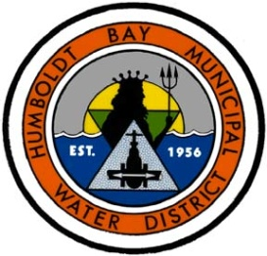

**Humboldt Bay Municipal Water District**

**828 Seventh Street**

**Eureka, CA 95501**

**June 9, 2016**

# **Table of Contents**

[Table of Contents i](#_Toc453943952)

[1 Introduction and Overview 1](#_Toc453943953)

[1.1 Background and Purpose 1](#_Toc453943954)

[2 Plan Preparation 2](#_Toc453943955)

[2.1 Basis for Preparing a Plan 2](#_Toc453943956)

[2.2 Regional Planning 2](#_Toc453943957)

[2.3 Individual or Regional Planning and Compliance 2](#_Toc453943958)

[2.4 Fiscal or Calendar Year and Units of Measure 3](#_Toc453943959)

[2.5 Coordination and Outreach 3](#_Toc453943960)

[3 System Description 4](#_Toc453943961)

[3.1 General Description 4](#_Toc453943962)

[3.2 Service Area 5](#_Toc453943963)

[3.3 Service Area Climate 6](#_Toc453943964)

[3.3.1 Climate Change 8](#_Toc453943965)

[3.4 Service Area Population and Demographics 8](#_Toc453943966)

[4 System Water Use 9](#_Toc453943967)

[4.1 Recycled versus Potable and Raw Water Demand 9](#_Toc453943968)

[4.2 Water Uses by Sector 9](#_Toc453943969)

[4.3 Distribution System Water Losses 10](#_Toc453943970)

[4.4 Climate Change 11](#_Toc453943971)

[5 SB X7-7 Baselines and Targets 12](#_Toc453943972)

[5.1 Guidance for Wholesale Agencies 12](#_Toc453943973)

[5.2 Updating Calculations from 2010 UWMP 13](#_Toc453943974)

[5.3 Baseline Periods 13](#_Toc453943975)

[5.4 Service Area Population 13](#_Toc453943976)

[5.5 Gross Water Use 13](#_Toc453943977)

[5.6 Baseline Daily Per Capita Water Use 13](#_Toc453943978)

[5.7 2015 and 2020 Targets 13](#_Toc453943979)

[5.8 2015 Compliance Daily per Capita Water Use (GPCD) 13](#_Toc453943980)

[5.9 Regional Alliance 13](#_Toc453943981)

[6 System Demands 14](#_Toc453943982)

[6.1 Purchased or Imported Water 14](#_Toc453943983)

[6.2 Groundwater 14](#_Toc453943984)

[6.3 Surface Water 15](#_Toc453943985)

[6.4 Stormwater 15](#_Toc453943986)

[6.5 Waste water and Recycled Water 15](#_Toc453943987)

[6.6 Desalinated Water Opportunities 15](#_Toc453943988)

[6.7 Exchanges or Transfers 15](#_Toc453943989)

[6.8 Future Water Projects 16](#_Toc453943990)

[6.9 Summary of Existing and Planned Sources of Water 16](#_Toc453943991)

[6.10 Climate Change Impacts to Supply 20](#_Toc453943992)

[7 Water Supply Reliability 21](#_Toc453943993)

[7.1 Constraints on Water Sources 21](#_Toc453943994)

[7.1.1 Water Quality 21](#_Toc453943995)

[7.2 Reliability by Type of Year 22](#_Toc453943996)

[7.2.1 Normal Water Year 23](#_Toc453943997)

[7.2.2 Single Dry Water Year 24](#_Toc453943998)

[7.2.3 Multiple Dry Water Years 25](#_Toc453943999)

[7.3 Supply and Demand Assessment 25](#_Toc453944000)

[7.4 Regional Supply Reliability 26](#_Toc453944001)

[8 Water Shortage Contingency Planning 27](#_Toc453944002)

[8.1 Plan Overview and Coordination 27](#_Toc453944003)

[8.1.1 Overview 27](#_Toc453944004)

[8.1.2 Coordination 29](#_Toc453944005)

[8.2 Safe Reservoir Yield During a Drought 29](#_Toc453944006)

[8.3 Stages of Action 32](#_Toc453944007)

[8.3.1 Stages and Conditions 32](#_Toc453944008)

[8.4 Prohibitions on End Uses 37](#_Toc453944009)

[8.5 Penalties, Charges, Other Enforcement of Prohibitions 37](#_Toc453944010)

[8.6 Consumption Reduction Methods 38](#_Toc453944011)

[8.7 Determining Water Shortage Reductions 39](#_Toc453944012)

[8.8 Revenue and Expenditure Impacts 39](#_Toc453944013)

[8.9 Resolution or Ordinance 40](#_Toc453944014)

[8.10 Catastrophic Supply Interruption 40](#_Toc453944015)

[8.11 Minimum Supply Next Three Years 41](#_Toc453944016)

[9 Demand Management Measures 44](#_Toc453944017)

[9.1 Demand Management Measures for Wholesale Agencies 44](#_Toc453944018)

[9.1.1 Metering 44](#_Toc453944019)

[9.1.2 Public education and outreach 45](#_Toc453944020)

[9.1.3 Water conservation program coordination and staffing support 45](#_Toc453944021)

[9.1.4 Other demand management measures 45](#_Toc453944022)

[9.1.5 Asset management 46](#_Toc453944023)

[9.1.6 Wholesale supplier assistance programs 47](#_Toc453944024)

[9.2 Demand Management Measures for Retail Agencies 47](#_Toc453944025)

[9.3 Implementation over the Past Five Years 48](#_Toc453944026)

[9.4 Planned Implementation to Achieve Water Use Targets 49](#_Toc453944027)

[9.5 Member of the California Urban Water Conservation Council 49](#_Toc453944028)

[10 Plan Adoption, Submittal, and Implementation 49](#_Toc453944029)

[10.1 Inclusion of All 2015 Data 50](#_Toc453944030)

[10.2 Notice of Public Hearing 50](#_Toc453944031)

[10.3 Public Hearing and Adoption 51](#_Toc453944032)

[10.4 Plan Submittal 51](#_Toc453944033)

[10.5 Public Availability 52](#_Toc453944034)

[10.6 Amending an Adopted UWMP 52](#_Toc453944035)

Figures

Figure 1 – District Service Area……………………………………….………………….6

Figure 2 – Mad River Watershed Assessment: Mean Annual Precipitation……………..7

Figure 3 – Ranney Will Along Mad River………………………………………………14

Figure 4 – Location Map of Ruth Lake………………………………………………….17

Figure 5 – R.W. Matthews Dam and Ruth Lake………………………………………...18

Figure 6 – Rippl Mass Diagram………………………………………………………….31

Figure 7 – Ruth Lake Operating Curves…………………………………………………35

Figure 8 – Ruth Reservoir water storage levels for the driest three consecutive years of record…………………………………………………………..…………….43

Figure 9 – Rippl Mass Diagram with ’76 – ’77 drought hydrologic information repeated for a three-year planning period……………………………...…………………….44

Figure 10 – Northcoast Regional Water Conservation Group display at Humboldt County Fair…………………………………………………………………………….49

Tables: Wholesale only tables have been included in each section.

**APPENDIX**

Appendix A

Urban Water Management Plan checklist, organized by Water Code and Subject

Appendix B

Plan Adoption, Submittal, and Implementation Documents

* 1. 60 Day Notification of UWMP Review and Adoption Hearing
  2. Certificate of Publication of the Legal Notice of Public Hearing
     1. The Times-Standard
     2. Mad River Union
     3. North Coast Journal Inc.
  3. District’s Board Agenda Item to Conduct Public Hearing for the District’s 2015 UWMP
  4. Board Resolution Adopting the District’s 2015 UWMP (Resolution No. 2016-06)
  5. Proof of Plan Submittal to DWR and other agencies
  6. Documentation showing that Adopted UWMP was available for public review
  7. Sample 2015 UWMP Municipal Work Group Meeting Agenda and Attendance (Sample Meeting from April 2016)
  8. Notification of Public Hearing to Agencies with Land Use Planning Authority and the District’s Municipal Customers

Appendix C

HBMWD- Water Resource Planning: Implementation Plan to Consider, Evaluate and as appropriate, Advance Recommended Water-use Options (Adopted August 11, 2011)

Appendix D

State Water Resources Control Board- Order WRO – 2004 – 0038: In the Matter of Permits 11714 and 11715 Regarding Diversions by HBMWD

Appendix E

HBMWD Ground Water Management Plan (April 2006)

Appendix F

Sample Resolution of the HBMWD Board of Directors Declaring a Water Shortage Emergency and Implementing the District’s Water Shortage Contingency Plan

Appendix G

North Coast Integrated Regional Water Management Plan – Phase III (August 2014), Appendix N “Climate Change Vulnerability Assessment”

Appendix H

HBMWD Resolutions (2014-2015) enacting Prohibited Activities in Promotion of Water Conservation

Appendix I

2015 Water Audit

**LIST OF ACRONYMS AND ABBREVIATIONS**

AFY acre-feet per year

BMP Best Management Practices

CSD(s) Community Services District(s)

cfs cubic feet per second

County Humboldt County

GIS geographic information system

HBMWD/District Humboldt Bay Municipal Water District

HCPD Humboldt County Planning Division

DMMs Demand Management Measures

DWR California Department of Water Resources

DOF California Department of Finance

Guidebook 2015 UWMP Guidebook by DWR (March 2016)

GPU Humboldt County’s General Plan Update

MG million gallons

MGD million gallons per day

PRA Peak Rate Allocation

Plan Urban Water Management Plan

USGS United States Geological Survey

UWMP Urban Water Management Plan

UWMP Act Urban Water Management Planning Act

**Humboldt Bay Municipal Water District**

**Urban Water Management Plan**

**2015**

# Introduction and Overview

## Background and Purpose

This Urban Water Management Plan (UWMP) for the Humboldt Bay Municipal Water District (HBMWD or District) has been prepared in accordance with the California Urban Water Management Planning Act of 1983 (AB 797) (UWMP Act) as amended, including amendments made per the Water Conservation Bill of 2009 (SBX7-7). In addition, the 2015 UWMP Guidebook was utilized in the preparation of the District’s 2015 UWMP. The overall intent of the UWMP is to provide long-term water supply and resource planning. The UWMP describes an urban water supplier’s water supplies and demands, as well as conservation efforts. The District’s UWMP relies upon its knowledge and ability to consider the unique circumstances of our water agency. This Plan contains all information required by the California Water Code, Division 6, Part 2.6. This is the seventh such plan prepared by the District. The last plan was submitted in June 2011.

The District operates a regional water system and provides service at the wholesale level. Since the early 1960s, the District has reliably supplied water to customers in the greater Humboldt Bay area of Humboldt County, California. The District provides treated, potable water for domestic and business use to seven municipalities (wholesale customers), as well as approximately 200 retail customers. From the early 1960s to the 1990s, the District also provided untreated surface water to two industrial customers (pulp mills). However, one of the larger pulp mills closed down in the 1990s and the last pulp mill unexpectedly ceased operation in 2009. As a result of these changes in customers and water demands, the District now has more than enough supply to serve existing customers. As noted in sections below, the District is evaluating options for the use of this additional water supply, including expansion of demand within its service territory, transfers to other users and dedication of portions of its water rights to streamflow enhancement.

The data used for preparing this report comes primarily from the District’s operational records. Figures relating to watershed runoff were obtained from the United States Geological Survey (USGS). Current and projected population figures for Humboldt County (County) are based on data from the California Department of Finance (DOF) with guidance from the Humboldt County Planning Department (HCPD). In some sections, tables of information suggested in the DWR 2015 UWMP Guidebook (Guidebook) are not applicable to the District. However, a majority of the tables from the Guidebook have been incorporated into this UWMP to help DWR’s review process, even if they are not applicable to the District. The UWMP Checklist has also been included in Appendix A to support DWR’s review process.

# Plan Preparation

## Basis for Preparing a Plan

According to the UWMP Act, all water suppliers with more than 3,000 connections or distributing more than 3,000 acre-feet per year (AFY) of water shall complete an UWMP every five years ending in ‘5’ and ‘0.’ HBMWD is an urban water supplier, and is preparing this Urban Water Management Plan pursuant to CWC 10617 et seq. HBMWD supplies more than 3,000 acre-feet per year of potable water to seven retail water suppliers, and is preparing this update under the category of a wholesale water supplier. HBMWD is required to provide this update to its UWMP by July 1, 2016.

## Regional Planning

HBMWD participates in the North Coast integrated regional water management planning group, known as the North Coast Resources Partnership. HBMWD representatives have served on the technical advisory committee which analyzes projects proposed for funding with IRWM water bond funds. HBMWD has been the recipient of these funds for various water supply infrastructure projects.

HBMWD also collaborates closely with its seven wholesale water supply customers, meeting with them monthly to address water quality and supply regulatory requirements, operational and infrastructure replacement needs, and funding needs.

## Individual or Regional Planning and Compliance

HBMWD has prepared this UWMP in conjunction with its wholesale water supply customers who are responsible for preparing UWMPs. Each of these organizations has chosen to define their own SB x7-7 compliance targets and reporting programs, so there is not a regional UWMP or regional alliance.



## Fiscal or Calendar Year and Units of Measure

HBMWD has prepared this UWMP using calendar year data. The typical units of measure in this UWMP are acre-feet.



## Coordination and Outreach

The District collaborated with multiple local and stakeholder agencies in preparation of this UWMP. This effort was conducted to inform the agencies of the planning activities of the District, to gather quality data for use in this UWMP, and to coordinate with other regional plans and initiatives. To that end, the District worked with its four larger municipal customers that qualify as Urban Water Suppliers as defined by the Urban Water Management Plan Act: City of Arcata, City of Eureka, Humboldt Community Services District, and McKinleyville Community Services District. The District provided assistance and information needed by these agencies for the preparation of their UWMPs and they reciprocated. Meetings were conducted from October 2015 through June 2016 between the District and these agencies, which were called 2015 UWMP Work Group Meetings. Other local water suppliers in the area, including the District’s three remaining wholesale customers and the City of Fortuna, were also invited to attend these meetings. Appendix B shows a sample Work Group Meeting Agenda and signup sheet. All seven of the District’s wholesale customers were provided with copies of the District’s adopted plan.

In addition to the above coordination efforts, notification was provided to local city and county land-use planning agencies prior to the UWMP public hearing that the District was in the process of reviewing and updating its UWMP. Appendix B contains a copy of the 60-day Notification (B-1).



# System Description

## General Description

HBMWD operates two separate and distinct water systems: a domestic water system which supplies treated drinking water; and an industrial system which supplies untreated raw water to large industrial users for industrial purposes. HBMWD’s system consists of the following facilities:

* R. W. Matthews Dam which forms Ruth Reservoir in southern Trinity County
* Gosselin Hydro-Electric Power House at Matthews Dam
* Diversion, pumping and control facilities adjacent to the Mad River near Essex at the John R. Winzler Operations and Control Center
* Storage and treatment facilities
* Two separate and distinct pipeline systems which deliver treated drinking water or untreated raw water to HBMWD's customers.

R. W. Matthews Dam impounds runoff from the upper quarter of the Mad River basin, an area of approximately 121 square miles. The capacity of Ruth Reservoir, impounded by Matthews Dam, is 48,030 acre-feet.

A portion of the water stored in Ruth Lake is released each summer and fall to satisfy HBMWD’s downstream diversion requirements, as well as maintain minimum bypass flow requirements in the Mad River below Essex. Although HBMWD impounds water at Ruth Lake and diverts water at Essex, the operations do not significantly affect the natural flow regime in the Mad River. There are several reasons for this, described as follows.

The total volume of water impounded and diverted by HBMWD represents a small percentage of the natural yield of the Mad River watershed. The Mad River’s average annual discharge into the Pacific Ocean is just over 1,000 ,000 acre-feet. Ruth Reservoir, in its entirety, represents less than 5% of the total average annual runoff from the Mad River basin. The total 48,030 AF capacity of Ruth Reservoir is not drawn down each year, so the amount of winter-season runoff captured in the reservoir is yet a smaller percentage of the total runoff. With respect to diversions, the current withdrawal rate at Essex averages 10 million gallons per day (11,000 AF per year), which is only 1% of the total annual average runoff of the Mad River watershed. This diversion is accomplished by extracting river water from the underlying aquifer via Ranney Collectors. In the winter months, additional filtration is provided by an in-line filtration facility. The full diversion capacity of 75 MGD (84,000 acre-feet per year) is just 8 % of the total annual average runoff of the watershed. The balance of the capacity above that diverted via the Ranney Collectors can be pumped from a screened surface diversion, also at Essex.

## Service Area

The District is located in Humboldt County and serves the greater Humboldt Bay region (Figure 1). The District was established in 1956 to provide municipal and industrial water for the area. The District’s service area includes the most heavily populated and developed parts of the County.

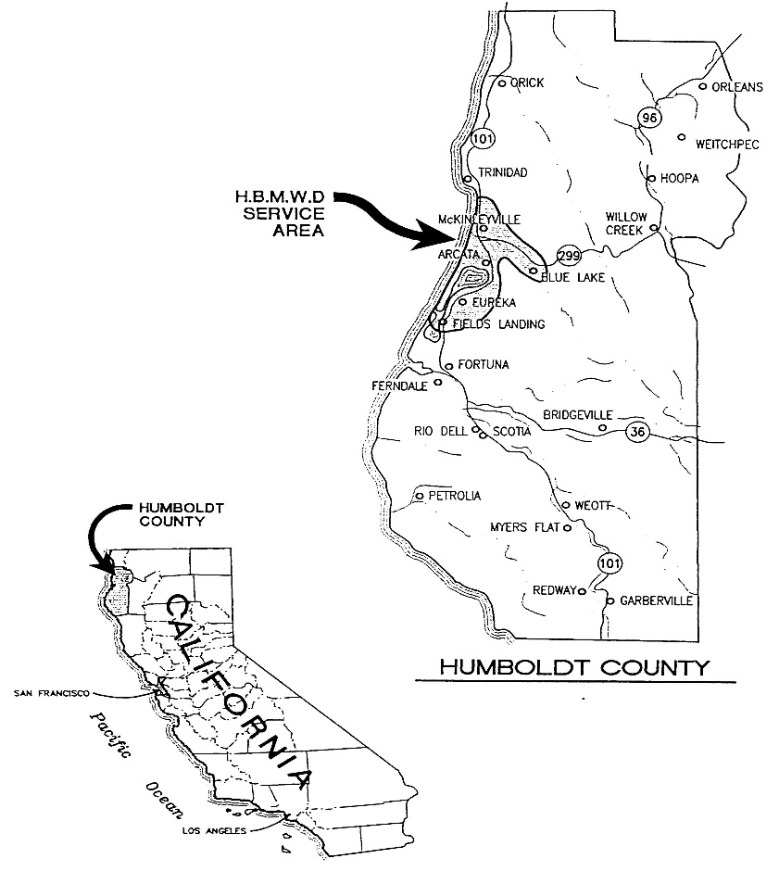

Figure 1 – District Service Area.

## Service Area Climate

Humboldt County’s watersheds receive high annual rainfall. According to the National Oceanic and Atmospheric Administration (NOAA) and the Western Regional Climate Center (WRCC), rainfall at Eureka averages just less than 40 inches per year (data from 7/1/1948 to 9/30/2010). At Ruth, in Trinity County, where the District operates the R.W. Matthews Dam and the Ruth Reservoir, average rainfall is approximately 60 inches per year (data from 1/1/1930 to 7/31/1985). Some mountainous areas within the region often receive more than 100 inches of rain per year, mostly during the period from November to April. Figure 2 shows the mean annual precipitation in the Mad River Watershed.

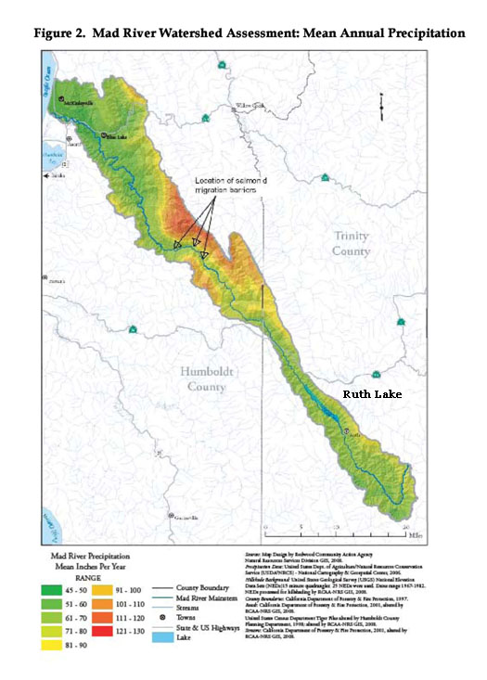

Rainfall, temperatures and evaporation are discussed further in Section 6.10 and in the North Coast Integrated Regional Water Management Plan’s “Climate Change Vulnerability Assessment” in Appendix G.

### Climate Change

HBMWD’s dam, reservoir and diversion facilities are not at risk due to factors associated with climate change – sea level rise or changes in precipitation intensity. Water supplies could be affected by changing precipitation patterns. However, predictions of precipitation pattern changes associated with global circulation models project that the Pacific Northwest (including the North Coast of California) will receive increased rainfall, while the Southwestern U.S., including Southern California, will likely become drier.

In an analysis completed in 2015, HBMWD identified a water supply delivery level of at least 36 MGD (Compared to the 10 MGD delivered in 2015) would be sustainable even under continuous hydrologic conditions similar to those experienced in 1976-77. Even this result is a conservative assessment, as it also assumes that diversions are directly at Ruth Dam, rather than 75 miles downstream at Essex, where intervening accretions in river flow would provide even more water supply available for diversion.

## Service Area Population and Demographics

The District used data from the California Department of Finance (DOF) to determine the estimated population served by the District. Guidance was also provided by staff at the Humboldt County Planning Division (HCPD) in regard to the County’s General Plan Update (GPU) and district boundaries. HCPD staff used the GPU to help identify areas within the County that had higher growth rates, or more potential growth than others.

In 2007, DOF created a database with individual files for each county in the State containing population data for the year 2000 and population projectionsup to the year 2050. This database is titled, “Race/Ethnic Population with Age and Sex Detail, 2000-2050.” Humboldt County’s population projection through 2035 was taken from this database. The County’s population estimates from 2015 through 2030 yield a projected average annual growth rate in Humboldt County of approximately 0.8%.

Staff at the HCPD helped to determine the District’s service area population as a percentage of the County’s population by using Census blocks and the County’s geographical information system (GIS) for city and district boundaries. The result was that for 2015, the District’s service area population is approximately 65% of the population of Humboldt County. Therefore, the District’s population has been projected at 65% of the County’s population through the year 2035 in 5-year increments (Table 3-1W). Since the average annual growth rate in Humboldt County from 2010 to 2030 is projected to be 0.8%, the District’s service area population is assumed to increase by 0.8% per year.

|  |  |  |  |  |  |  |
| --- | --- | --- | --- | --- | --- | --- |
| **Table 3-1 Wholesale: Population - Current and Projected** | | | | | | |
| Population Served | 2015 | 2020 | 2025 | 2030 | 2035 | 2040*(opt)* |
| 88,223 | 91,808 | 95,540 | 99,423 | 103,464 |  |
| NOTES: District's population is approximately 65% of Humboldt County's population. Per US Census, Humboldt County's population growth rate from 2010-2015 is 0.80%, this growth rate was applied to District's population growth per year. | | | | | | |

# System Water Use

## Recycled versus Potable and Raw Water Demand

Recycled water is covered in more detail in Section 6.5. As shown in Table 4-3 below, there is no current or projected demand for recycled water within the HBMWD service territory.

## Water Uses by Sector

Total water use, and use by sector (municipal customer) for HBMWD’s wholesale water service area is defined in Table 4-1:

|  |  |  |  |
| --- | --- | --- | --- |
| **Table 4-1 Wholesale: Demands for Potable and Raw Water - Actual (AFY)** | | | |
| Use Type *(Add additional rows as needed)* | 2015 Actual | | |
| ***Drop down list*** *May select each use multiple times These are the only use types that will be recognized by the WUE data online submittal tool* | Additional Description *(as needed)* | Level of Treatment When Delivered *Drop down list* | Volume |
| Sales to other agencies | City of Arcata | Drinking Water | 1,995 |
| Sales to other agencies | City of Blue Lake | Drinking Water | 379 |
| Sales to other agencies | City of Eureka | Drinking Water | 4,247 |
| Sales to other agencies | Fieldbrook CSD | Drinking Water | 174 |
| Retail demand for use by agencies that are primarily wholesalers with a small volume of retail sales | HBMWD Retail Customers | Drinking Water | 619 |
| Sales to other agencies | Humboldt CSD | Drinking Water | 973 |
| Sales to other agencies | Manila CSD | Drinking Water | 118 |
| Sales to other agencies | McKinleyville CSD | Drinking Water | 1,397 |
| Losses | Water Loss Audit 2015 | Drinking Water | 59 |
| **TOTAL** | | | 9,961 |
| NOTES: The District sells drinking water to seven wholesale customers and approximately 200 retail customers. | | | |

Projected water use is described in Table 4-2:



Total water demands projected into the future are provided in Table 4-3:

|  |  |  |  |  |  |  |
| --- | --- | --- | --- | --- | --- | --- |
| **Table 4-3 Wholesale: Total Water Demands** | | | | | | |
|  | 2015 | 2020 | 2025 | 2030 | 2035 | 2040*(opt)* |
| Potable and Raw Water *From Tables 4-1 and 4-2* | 9,961 | 22,145 | 33,895 | 45,581 | 57,290 | 0 |
| Recycled Water Demand\* *From Table 6-4* | 0 | 0 | 0 | 0 | 0 | 0 |
| **TOTAL WATER DEMAND** | 9,961 | 22,145 | 33,895 | 45,581 | 57,290 | 0 |
| *\*Recycled water demand fields will be blank until Table 6-4 is complete.* | | | | | | |

## Distribution System Water Losses

HBMWD conducted a water loss audit, using the AWWA water audit software. AWWA Cal-Nevada staff was contacted for guidance on preparation of the water loss audit, which is attached as Appendix I. HBMWD’s water balance calculations are shown in the following table:



As shown in Table 4-4, HBMWD’s water losses in 2015 were 59.402 acre-feet:

|  |  |
| --- | --- |
| **Table 4-4 Wholesale: 12 Month Water Loss Audit Reporting** | |
| Reporting Period Start Date (mm/yyyy) | Volume of Water Loss\* |
| 01/2015 | 59.402 |
| *\* Taken from the field "Water Losses" (a combination of apparent losses and real losses) from the AWWA worksheet.* | |
| NOTES: Reporting data from 2015 calendar year. | |

## Climate Change

The North Coast Resources Partnership, which is the governing body for the integrated regional water management plan for the North Coast region of California (which stretches from Sonoma County north to the Oregon border and east to Trinity, Siskiyou and Modoc Counties) has conducted a climate change vulnerability assessment. This assessment was conducted in 2014 and is included in this Plan as Appendix G.

The assessment evaluated potential impacts on 11 different sectors: four natural ecosystems – forest, rangeland, riparian and coastal; and seven built/human/economic systems – agriculture, forestry, fisheries, water supply/demand, energy capacity/demand and recreation. Various climate models and emission scenarios were then used to develop a basin characterization model that itself was used to project likely changes to climate and hydrology in the north coast region. The impacts of these climate and hydrology changes on the eleven sectors were then evaluated and the sensitivity and adaptive capacity of the eleven sectors to climate change were projected for the various watersheds in the north coast region. Based on the sensitivity and adaptive capacity, the vulnerability of the sectors to climate change was then ranked into three categories: high, medium and low. The principal reference used to define these changes was a 2012 paper prepared for the California Energy Commission by Thorne, J. H., R. Boynton, L. Flint, A. Flint, T. N. Le, entitled “Development and Application of Downscaled Hydroclimatic Predictor Variables for Use in Climate Vulnerability and Assessment Studies.”

Overall, water supply and demand are projected to be of low to moderate vulnerability of climate change in the north coast region in general, and even less so in the Mad River watershed. The Mad River watershed is rainfall-dominated (little to no snowpack), and annual demand on water supplies available from the watershed are typically well below 10% of mean runoff. As noted in Section 3.3.1, HBMWD has estimated that demand up to 36 MGD (compared to a current annual average usage of 10 MGD) could be met reliably, even if the unprecedented condition of continuous hydrology similar to the 1976-77 drought occurred.

Instream flow requirements in the Mad River are consistently met, and are adequate to protect the ecosystem, which includes a number of threatened or endangered aquatic species. Similarly, beneficial uses in the Mad River are consistently supported and are expected to continue to be so into the future. Two of HBMWD’s seven wholesale customers rely for a portion of their supply on coastal aquifers, but saltwater intrusion and drought resiliency has not been a problem for these aquifers, nor is that situation expected to change into the future.

There is significant infrastructure in the HBMWD service area that is within six feet of mean sea level, including some portions of transmission pipelines operated by HBMWD, and distribution infrastructure operated by HBMWD’s wholesale customers.

# SB X7-7 Baselines and Targets

## Guidance for Wholesale Agencies

The Water Conservation Bill on 2009 (SBX7-7) has a goal to achieve a 20 percent reduction in per capita water use statewide by 2020. Per capita use of water in the area is below national and state averages. Current production of treated drinking water for municipal purposes averages 10 MGD. This municipal use includes residential, commercial, industrial and agricultural uses of the water. Per capita water use rates in this region are low and likely benefit greatly from the moderate climate and abundant rainfall, as needs for agriculture and landscaping are often met with rainfall rather than municipal water.

As the District is a *wholesale* water supplier and not an “urban retail water supplier,” per the 2015 UWMP Guidebook, the baseline and urban water use target calculations do not apply to the District. Therefore, as a wholesale water supplier, the District does not have to develop an implementation plan for compliance with the Water Conservation Bill of 2009.

Although the District does not have to establish these baseline and water use targets, the District has supported and will continue to support its wholesale water customers (who are urban retail water suppliers) with their water conservation programs, and to help them achieve their Interim and Final urban water use reduction targets. Section 9.3 shows the District’s participation in various public education and outreach activities with the other four larger water agencies over the past five years.

## Updating Calculations from 2010 UWMP

This section applies to Retail service water agencies only.

## Baseline Periods

This section applies to Retail service water agencies only.

## Service Area Population

This section applies to Retail service water agencies only.

## Gross Water Use

This section applies to Retail service water agencies only.

## Baseline Daily Per Capita Water Use

This section applies to Retail service water agencies only.

## 2015 and 2020 Targets

This section applies to Retail service water agencies only.

## 2015 Compliance Daily per Capita Water Use (GPCD)

This section applies to Retail service water agencies only.

## Regional Alliance

This section applies to Retail service water agencies only.

# System Demands

## Purchased or Imported Water

The source of water distributed by the District is from the Mad River. The R.W. Mathews dam, located in Trinity County, impounds water to form Ruth Reservoir (Figure 2). The Mad River flows from Trinity County into Humboldt County where water is diverted at the District’s Essex pumping facility located approximately 75 miles downstream from the dam. The District does not purchase or import water from any other source.

## Groundwater

At the District’s Essex Operations Center, municipal water is pumped from the aquifer beneath the Mad River by four Ranney wells. Figure 1 shows a close-up of the District’s Ranney wells along the Mad River. The groundwater that is pumped by the Ranney wells is continually recharged by surface water from the Mad River, part of which is released from Ruth Lake pursuant to the District’s water rights permits.

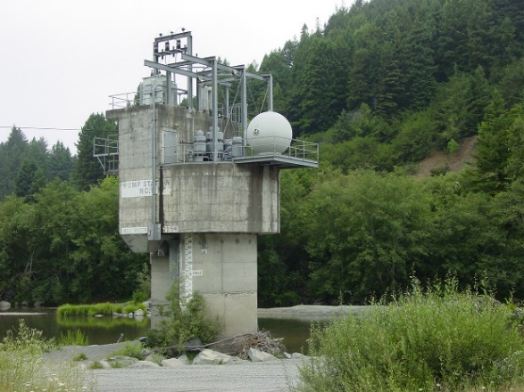

Figure 3. Ranney Well along Mad River, close-up.

### Basin Description

In 2006, the District completed a Groundwater Study of the aquifer in the Essex Reach of the Mad River in the vicinity of the Ranney Wells. This study was done to support the District’s Capital Improvement Plan, and in particular, to better understand the basin hydrology and the interactions between the Ranney wells and the surrounding environment for the projects proposed. The site studied was the Mad River Groundwater Basin which is located in the North Coast Hydrologic Region. It is composed of the Mad River Lowland Sub-basin (Basin #1-8.01) and the Dows Prairie Subbasin (Basin #1-8.02), as defined by DWR.

The Mad River Lowland Sub-basin includes the coastal floodplain from the Freshwater Fault north to the Mad River and the elevated terrace areas to the east. The basin is bounded by Arcata Bay to the south, the Mad River to the north, and mountains to the east. The basin also includes Blue Lake Valley to the east. Between Mad River and Arcata Bay, the coastal plain is dissected by flood stage channels of the Mad River that are 15- to 20-feet deep. The Mad River discharges to the ocean approximately 5 miles north of Arcata Bay and is tidal for about 1 mile inland. The Mad River Groundwater Basin in the Blue Lake Valley and in the Mad River floodplain is composed of alluvium and is underlain by the Hookton Formation. Sand dunes are present along the coastline edge of the basin. The upland areas to the north and east are above the alluvium of the river floodplain and are comprised solely of the Hookton Formation. The entire basin area is underlain by bedrock. Seawater intrusion has occurred in the shallow aquifers near the ocean and bay areas. However, seawater is not present to any appreciable extent landward of the coastline.

The Dows Prairie Sub-basin is located on the coast north of the Mad River Lowland Sub-basin and is bounded by Little River to the north and Mad River to the south. The sub-basin is bounded to the east by bedrock outcroppings. The sub-basin is part of an elevated terrace drained by several small creeks. Development of groundwater is primarily in the western portion of the sub-basin. The Hookton Formation is the main geologic unit in the area. The Franciscan Formation underlies the Hookton Formation and is essentially a non-water-bearing unit.

There is no present or anticipated overdraft in the two subbasins. The specific location of the study is the Holocene River Channel Deposits in the Mad River Lowland Subbasin. The Study was conducted in accordance with Assembly Bill 3030 and was used to produce the District’s Groundwater Management Plan (GWMP) (Appendix E).

The District’s GWMP has further descriptions of the Mad River Goundwater Basin, its two subbasins, and basin map (Section 3.2 of GWMP).

### Groundwater Management

The Groundwater Management Act, California Water Code, Part 2.75, §10753, also known as Assembly Bill 3030 (AB 3030), provides public agencies with the authority to prepare groundwater management plans. The intent of AB3030 is to promote cooperative management of groundwater resources by local agencies and stakeholders within groundwater basins. In recognition of the importance of the groundwater resources to the overall water supply needs of water users and land owners in the Mad River region, the District’s Board of Directors authorized the preparation of a GWMP with Resolution 2005-3, which was passed at an advertised public hearing in March 2005.

The scope of the District’s GWMP (Appendix E) addresses groundwater management issues impacting groundwater extraction in the Lower Mad River Area, in particular, the groundwater basin used by the District. A large portion of Humboldt County’s population uses groundwater from the Mad River Basin, mainly through the District’s distribution system. This GWMP addresses specific issues as requested by AB 3030 as well as other issues relevant to the area.

At this point there has been no adjudication of groundwater within the Mad River Groundwater Basin.

### Overdraft Conditions

As mentioned earlier, there is no present or anticipated overdraft in the Mad River Basin and its two subbasins.

### Historical Groundwater Pumping

As mentioned earlier, municipal water is pumped from the aquifer beneath the Mad River by four Ranney wells at the District’s Essex Operations Center. Since the water pumped by the Ranney wells is continually recharged by surface water from the Mad River, the groundwater pumped has been sufficient to meet demands for the last five years and into the foreseeable future. The District does not have any current or planned groundwater supply additions to its Domestic or Industrial Water Systems.

Table 6-1 below shows the District’s historical groundwater pumped from the Mad River Groundwater Basin and sold the District’s wholesale and retail customers.



## Surface Water

At the District’s Essex Operations Center located just northeast of Arcata, municipal water is pumped from the aquifer beneath the Mad River by four Ranney wells. These Ranney wells are situated within the riverbed at depths ranging from approximately 60 to 90 feet. The water that is pumped by the Ranney wells is continually recharged by surface water from the Mad River, a portion of which is released from Ruth Lake pursuant to the District’s water rights permits. The District has appropriative water rights permits from the State Water Resources Control Board through the year 2029 for surface water storage and diversion. These are Permit No. 11714 and Permit No. 11715 respectively.

The District‘s Industrial Water System is separate and distinct from its Domestic Water System. From the early 1960s to the 1990s, the District also provided untreated surface water to two industrial customers (pulp mills). This Industrial Water System is capable of supplying 60 MGD of untreated water. However, one of the larger pulp mills closed down in the 1990s and the last pulp mill unexpectedly ceased operation in 2009. With no existing industrial customer, the District has an opportunity to support future water supply needs.

## Stormwater

The District has ample supply to meet all its customer demands. The District does not have a stormwater recovery system.

## Waste water and Recycled Water

The District is a regional water wholesaler and does not operate or have any authority over wastewater collection and treatment in the area. Some of the District’s larger municipal customers provide both water and sewer services to their customers. Information about these systems and their water recycling programs may be found in their respective UWMPs. Therefore the following tables—Tables 6-3 W, 6-4 W, and 6-5 W dealing with recycled water are not applicable to the District.

## Desalinated Water Opportunities

Due to the abundant fresh water supply, development of desalinated water is not a necessary or cost effective option for the District. Therefore, the District is not considering development of desalinated water supplies within the planning horizon of the 2015 UWMP.

## Exchanges or Transfers

In 2009, the District lost its last industrial customer for its Industrial Water System. In 2011, the District developed a Water Resource Planning (WRP) Implementation Plan that addresses the loss of its customer base and established three water-use options the District will consider and as appropriate, pursue (Appendix C). One option is the transfer of water for use outside of the District’s existing service territory to another public water agency for a “beneficial use.” This option has the potential to transfer up to 40 MGD or 44,800 AFY of water (pursuant to the demand objectives of the other two options).

A transferee agency (or agencies) is unknown at this time. The District is still in the planning process and is in discussions with neighboring water-associated agencies such as City of Fortuna, City of Rio Dell, Trinidad Rancheria, City of Trinidad, and water agencies further south (such as those in the San Francisco Bay Area.) The District is evaluating all the water use options as categorized in the WRP Implementation Plan.

## Future Water Projects

As previously discussed, the District has an abundance of water to supply its customers. This abundance of water will be available to the District in average, single-dry, and multiple-dry water years, as will be discussed in the following sections. Therefore, no new water supply projects that create a brand *new source* *of supply* are planned or deemed necessary at this time. Table 6-7 W (Expected Future Water Supply Projects or Programs) is not applicable.

## Summary of Existing and Planned Sources of Water

The source of water distributed by the District is from the Mad River, located in Trinity and Humboldt Counties, and Ruth Reservoir, which is located in Trinity County (Figure 2). R.W. Matthews Dam, located at river mile 79, impounds water in Ruth Lake (Figure 3). The District manages releases from the dam to ensure sufficient supplies downstream throughout the year.

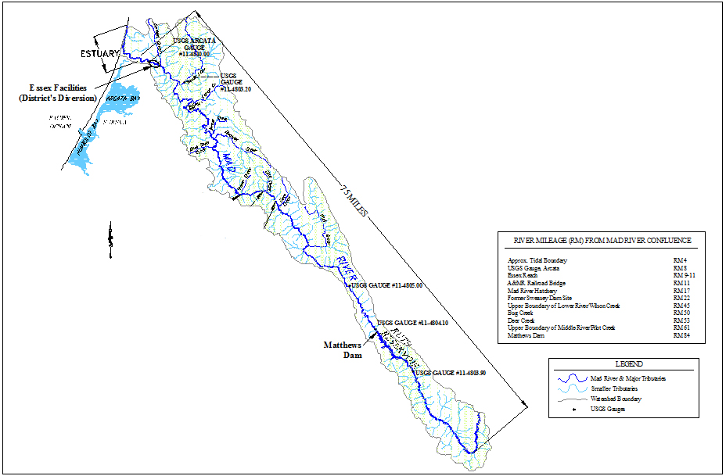Figure 4. Location Map of R.W. Mathews Dam and Ruth Lake.

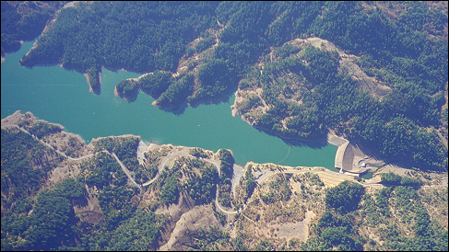

Figure 5. Aerial view of R.W. Matthews Dam and Ruth Lake.

At the District’s Essex Operations Center located just northeast of Arcata, water is diverted and pumped to meet demand. Municipal water is pumped from an aquifer beneath the Mad River by four Ranney wells situated within the riverbed at depths ranging from approximately 60 to 90 feet. Industrial water is diverted by a surface diversion facility.

The District has appropriative water rights permits from the State Water Resources Control Board through the year 2029 for surface water storage and diversion. These are Permit No. 11714 and Permit No. 11715 (Appendix D). Permit No. 11714 allows the District to store up to 48,030 AFY at Ruth Lake to be collected “from October 1 of each year to April 30 of the succeeding year.” Permit No. 11715 allows the District to directly divert up to 84,000 AFY (75 MGD) at the Essex facilities. This represents 8.8% of the average annual runoff (959,071 AFY) of the Mad River Basin for the period from 1963 to 2015 (average annual runoff data provided by USGS at Gage Station 1148100 on the Mad River near Arcata, CA). During the last five years (2011-2015), the District has diverted an average of 10,400 AFY for domestic consumption, which represents only 1.1% of the average annual runoff of the Mad River Basin and only 12.4% of the permitted maximum annual diversion.

During 2015, the District only diverted a total of 9,961 AF. Table 6-8 W shows the 2015 diversion from storage and from surface water supplies.

|  |  |  |  |  |
| --- | --- | --- | --- | --- |
| **Table 6-8 Wholesale: Water Supplies — Actual (AFY)** | | | | |
| *Jan -May* | Additional Detail on Water Supply | **2015** | | |
| ***Drop down list*** *May use each category multiple times.These are the only water supply categories that will be recognized by the WUEdata online submittal tool* | Actual Volume | Water Quality *Drop Down List* | Total Right or Safe Yield *(optional)* |
| *Add additional rows as needed* | | | | |
| Surface water | Mad River Storage and Diversions | 9,961 | Drinking Water | 84,000 |
|  |  |  |  |  |
| **Total** | | 9,961 |  | 84,000 |
| NOTES: Per SWRCB Order WRO-2004-0038, the maximum amount to be appropriated by direct diversion under Permit 11715 shall not exceed 84,000 afy. | | | | |

The City of Eureka (City) maintains water rights on the Mad River equivalent to 5.16 MGD. Under an agreement between the District and the City, the deliveries from the District to the City are considered to be deliveries of the City’s water, emanating from its own water rights, not those of the District. Deliveries to the City in excess of the City’s water rights are considered deliveries of the District’s water.

Because the District’s water supply capability is determined by its water rights and existing facilities, the projected supply is 84,000 AFY as shown in Table 6-9 W.



## Climate Change Impacts to Supply

Watersheds in both Humboldt County and Trinity County receive high annual rainfall. The climate of the lower Mad River watershed is influenced by the coastal atmosphere and averages 40 inches of rain per year between the months of October through April. Further inland, rain is predominant during these winter months up to 3,000 feet, with snow above 4,000 feet. The average rainfall in the upper watershed is approximately 65 inches.

|  |  |  |  |
| --- | --- | --- | --- |
| Month | Std Mo Avg ETo  (Evapotranspiration)  (Inches) | Average Rainfall  (Inches) | Average Temperature  Min - Max  (Fahrenheit) |
| Jan | 1.24 | 10.33 | 27.5 – 46.1 |
| Feb | 1.96 | 10.32 | 30.0 – 50.7 |
| Mar | 3.10 | 10.08 | 32.0 – 55.2 |
| Apr | 4.80 | 5.16 | 33.1 – 62.2 |
| May | 6.51 | 1.20 | 37.5 – 72.9 |
| Jun | 7.80 | 0.44 | 43.1 – 83.0 |
| Jul | 8.99 | 0.25 | 47.0 – 90.2 |
| Aug | 7.75 | 0.50 | 46.5 – 90.0 |
| Sep | 5.70 | 1.44 | 42.1 – 83.1 |
| Oct | 3.72 | 4.41 | 36.5 – 69.0 |
| Nov | 1.80 | 11.13 | 31.7 – 51.0 |
| Dec | 0.93 | 10.15 | 29.1 – 46.0 |
| Annual | 54.3 | 65.42 | 36.4 – 66.8 |

Rainfall and temperature are from the Forest Glen weather data gathering station which is the closest station to the Ruth area. This information is provided by WRCC and NOAA under the U.S. Department of Commerce. The rainfall and temperature data are for the period from 1971 to 2000 (latest available data).

Evapotranspiration data for the Ruth area is from the statewide ETo Map and Table. This information is provided by the California Irrigation Management Information System (CIMIS) operated by the Office of Water Use Efficiency under the Department of Water Resources (DWR). According to DWR, evapotranspiration is the loss of water to the atmosphere by the combined process of evaporation, typically from soil and plant surfaces, and transpiration from plant tissues. The data above shows that more evapotranspiration occurs in the summer months versus the in winter months. Evapotranspiration is a good indicator of how much water is needed by the surrounding vegetation for healthy growth and productivity.

The District participated in the North Coast IRWM Plan’s “Climate Change Vulnerability Assessment” (Appendix G) and with regards to Section II. Water Supply:

* A portion of the water supply comes from snow melt in the Mad River Watershed.
* Our water supply does not rely on water diverted from the Delta or coastal aquifers. Our main source of supply is from the Mad River in Trinity and Humboldt Counties and Ruth Lake in Trinity County.
* Our region will not have difficulty in storing carryover supply surpluses from year to year. Ruth Reservoir currently has a capacity of 48,030 acre-feet.
* Our region has not faced a drought in the past during which we failed to meet local water demands.
* Our region does not have any invasive species management issues at any facilities, along conveyance structures, or in habitat areas.

The District has not experienced a water shortage at any time during the recent drought in other parts of California (2012-15.) The District’s reservoir – Ruth Reservoir –has filled to capacity each and every year of the four-year drought. Due to the District’s full reservoir and reduced demands (loss of two large industrial customers), the District is not experiencing any water shortage, and has sufficient water supply to carry it through multiple future drought years.

# Water Supply Reliability

## Constraints on Water Sources

As discussed in the “System Demands” sections above, the District has an abundant supply of water at Ruth Reservoir which flows down the Mad River and is pumped at the Essex Operations Center (Figure 2). This source of water has been very consistent and there is no need to replace or supplement this source.

### Water Quality

As discussed above, drinking water delivered by the District is drawn from wells located in the Mad River. These wells draw water from the sands and gravel of the aquifer located under the riverbed. The gravel and sands through which the water is drawn provides a natural filtration process which yields source water for the District’s regional drinking water system that is of very high quality. Furthermore, the results from the District’s ongoing water monitoring and testing program indicate that the District’s water quality is very high and meets safe drinking regulatory standards, as has consistently been the case over the years.

The only water quality issue occasionally encountered by the District in the past was turbidity. Generally, turbidity in the Ranney Well source water has been very low and meets the turbidity standards set by the California Department of Public Health (CDPH), now known as the Division of Drinking Water (DDW). However, during or following severe winter storm events, turbidity in the source water could rise beyond the standards set by DDW. In the late 1990s, an extremely heavy “El Nino” rainy season caused a prolonged series of storms that raised turbidity in the source water to such a level that DDW became concerned that it could potentially interfere with the disinfection process, and therefore, pose a threat to public health. In 1997, DDW directed all of the Public Water Systems in the Humboldt Bay area (the District and its wholesale municipal customers) to address the wintertime turbidity issue and to meet the turbidity standards established by DDW. The District initiated a process with its seven wholesale customers to determine the most cost effective way to meet the State’s requirement. The solution was to design and construct a regional Turbidity Reduction Facility (TRF). The TRF was completed in April 2003 and now operates during the winter storm season to reduce higher turbidities in accordance with the State’s standards.

As the District’s ongoing water monitoring and testing program indicates that the District’s water quality has been and continues to be very high and with the turbidity issue taken care of by the TRF, the District does not foresee any current or projected water supply impacts resulting from water quality.

## Reliability by Type of Year

As stated in earlier sections, the District has permitted rights to store 48,030 AFY of Mad River water at Ruth Reservoir and divert 84,000 AFY of water at Essex to supply its wholesale and retail customers. Table 4-2 W and Table 7-2 show that the highest projected total water demand for the District’s wholesale customers in 2035 is 57,290 AFY, which is approximately 68% of this permitted water supply. With this in mind, the following sections will provide data for each of the following water year types: normal, single dry, and multi-dry. Supply and demand comparisons for each water year type will also be discussed.

Table 7-1 W captures the specific base water years that each type of water year falls into.

|  |  |  |  |
| --- | --- | --- | --- |
| **Table 7-1 Wholesale: Basis of Water Year Data** | | | |
| **Year Type** | **Base Year**  *If not using a calendar year, type in the last year of the fiscal, water year, or range of years, for example, water year 1999-2000, use 2000* | **Available Supplies if  Year Type Repeats** | |
| C:\Users\PROGRA~1\AppData\Local\Temp\msohtmlclip1\01\clip_image001.png | Quantification of available supplies is not compatible with this table and is provided elsewhere in the UWMP. Location \_\_\_\_\_\_\_\_\_\_\_\_\_\_ |
| C:\Users\PROGRA~1\AppData\Local\Temp\msohtmlclip1\01\clip_image002.png | Quantification of available supplies is provided in this table as either volume only, percent only, or both. |
| **Volume Available** | **% of Average Supply** |
| Average Year | 1989 | 985364 | 100% |
| Single-Dry Year | 1977 | 109107 | 11% |
| Multiple-Dry Years 1st Year | 1990 | 571815 | 58% |
| Multiple-Dry Years 2nd Year | 1991 | 371340 | 38% |
| Multiple-Dry Years 3rd Year | 1992 | 282794 | 29% |
| Multiple-Dry Years 4th Year *Optional* |  |  |  |
| Multiple-Dry Years 5th Year *Optional* |  |  |  |
| Multiple-Dry Years 6th Year *Optional* |  |  |  |
| Agency may use multiple versions of Table 7-1 if different water sources have different base years and the supplier chooses to report the base years for each water source separately. If an agency uses multiple versions of Table 7-1, in the "Note" section of each table, state that multiple versions of Table 7-1 are being used and identify the particular water source that is being reported in each table. | | | |
| NOTES: Average Year volume chosen based on average annual Mad River watershed discharges from 1963 - 2015. | | | |

### Normal Water Year

During a normal water year, the Ruth Lake area averages 65.42 inches of rainfall, about 173,000 AF of water flow into the reservoir via the Mad River, and the average runoff for the watershed near the District’s diversion facilities at Essex is 959,071 AFY (over the entire record period from 1963 to 2015). The average annual runoff data was provided by USGS at Gage Station 1148100 on the Mad River near Arcata, CA. As shown in Table 7-1 W, the Water Year ending in 1989 was considered an average water year because the average runoff for the watershed that year was 985,364 AFY, which is closest to the average annual runoff for the watershed as provided.

Table 7-2 W shows the normal year supply and demand comparison. During a normal water year, the Ruth Reservoir and Mad River watershed have enough supply to meet the District’s maximum permitted diversion of 84,000 AFY.

|  |  |  |  |  |  |
| --- | --- | --- | --- | --- | --- |
| **Table 7-2 Wholesale: Normal Year Supply and Demand Comparison** | | | | | |
|  | 2020 | 2025 | 2030 | 2035 | 2040 *(Opt)* |
| Supply totals *(autofill from Table 6-9)* | 84,000 | 84,000 | 84,000 | 84,000 |  |
| Demand totals *(autofill fm Table 4-3)* | 22,145 | 33,895 | 45,581 | 57,290 |  |
| Difference | 61,855 | 50,105 | 38,419 | 26,710 |  |
| NOTES: | | | | | |

### Single Dry Water Year

The water year ending in 1977 was the driest recorded for the District, far drier than any other. Rainfall in the Ruth area was 29 inches, or 41% of normal (69.8 inches). Flows into the reservoir were 26,000 AFY, or 15% of normal (173,000 AFY). The runoff for the watershed measured near the District’s diversion facilities was 109,107 AFY, or 11% of normal (959,071 AFY). The average reservoir volume for the water year was 21,000 AF, which is 44% of capacity (48,030 AF) and 51% of normal (41,000 AF). The reservoir was drawn down to 13,000 AF, or 27% of its capacity (48,030 AF) at the end of the water year.

Fall storms arrived in November 1977 and quickly refilled the reservoir. This water year was severely dry throughout the entire state of California and was a very exceptional year in the District’s history:

* In 52 years of records, it was the only year in which rainfall was less than 50% of normal (69.8 inches).
* It was also the only year in which the reservoir was not filled to capacity.
* Total flows into the reservoir via the Mad River were half the value of the next driest year (2001).
* Runoff for the watershed and average reservoir volume were each 60% of the next driest year.

Table 7-3 W shows the Single Dry Year supply and demand comparison. This supply was based on the 1977 water year with watershed runoff of 109,107 AFY. As this amount is more than the District’s permitted water supply of 84,000 AFY, the District still has the 84,000 AFY of water available as it does during a normal water year. Therefore, Table 7-3 W shows the same calculations as in Table 7-2 W for the normal water year condition showing the supply totals as 84,000 AFY from 2020 through 2035. The data shows that the District has more than enough water supply to meet demand, even in a critical single dry water year situation.

|  |  |  |  |  |  |
| --- | --- | --- | --- | --- | --- |
| **Table 7-3 Wholesale: Single Dry Year Supply and Demand Comparison** | | | | | |
|  | 2020 | 2025 | 2030 | 2035 | 2040 (Opt) |
| Supply totals | 84,000 | 84,000 | 84,000 | 84,000 |  |
| Demand totals | 22,145 | 33,895 | 45,581 | 57,290 |  |
| Difference | 61,855 | 50,105 | 38,419 | 26,710 |  |
| NOTES: | | | | | |

### Multiple Dry Water Years

The three water years between October 1989 and September 1992 represent the driest multiple years recorded for the District:

* Rainfall for this period averaged 42 inches per year, or 60% of normal.
* Of the three water years, the driest year for rainfall was water year 1990/1991 with 37 inches, or 53% of normal.
* Flows into Ruth Lake via the Mad River averaged 69,000 AFY, or 40% of normal (173,000 AFY).
* Despite the diminished rainfall and runoff, rainfall was more than sufficient to refill the reservoir each year.
* Reservoir volume during this period averaged 37,000 AF which is 77% of capacity (48,030
* AF) and 90% of normal (41,000 AF).

The runoff for the watershed above the District’s diversion facilities for these three water years were:

* 1990: 571,815 AFY, or 60% of normal (959,071 AFY).
* 1991 (driest water year of the three): 371,300 AFY, or 39% of normal.
* 1992: 282,794 AFY, or 29% of normal.

## Supply and Demand Assessment

Table 7-4 W projects the multiple dry water year supply amounts in comparison to projected demands for 2020 through 2035. Watershed runoff data from the three consecutive water years mentioned above were used, attributing 571,815 AFY (for First year), 371,340 AFY (for Second year), and 282,794 AFY (for Third year). As these supply amounts are larger than the District’s maximum permitted supply amount of 84,000 AFY, the District is able to maintain its water supply during these consecutive dry water years as well. Therefore, Table 7-4 W also shows the District’s water supply projections for multiple dry water years as its permitted amount of 84,000 AFY for 2020 through 2035. The data shows that the District has more than enough water supply to meet demand, even during multiple dry water years.

|  |  |  |  |  |  |  |
| --- | --- | --- | --- | --- | --- | --- |
| **Table 7-4 Wholesale: Multiple Dry Years Supply and Demand Comparison** | | | | | | |
|  |  | 2020 | 2025 | 2030 | 2035 | 2040 (Opt) |
| First year | Supply totals | 84,000 | 84,000 | 84,000 | 84,000 |  |
| Demand totals | 22,145 | 33,895 | 45,581 | 57,290 |  |
| Difference | 61,855 | 50,105 | 38,419 | 26,710 | 0 |
| Second year | Supply totals | 84,000 | 84,000 | 84,000 | 84,000 |  |
| Demand totals | 22,145 | 33,895 | 45,581 | 57,290 |  |
| Difference | 61,855 | 50,105 | 38,419 | 26,710 | 0 |
| Third year | Supply totals | 84,000 | 84,000 | 84,000 | 84,000 |  |
| Demand totals | 22,145 | 33,895 | 45,581 | 57,290 |  |
| Difference | 61,855 | 50,105 | 38,419 | 26,710 | 0 |

## Regional Supply Reliability

Throughout the years, there have been studies that refer to the District’s water source and its reliability. Bechtel Corporation was retained in the 1950s to perform various water supply studies and to complete the design and specifications for the original regional water system. During this time, Bechtel completed a detailed operations study of the reservoir storage to determine the safe yield of the original project pursuant to the District’s downstream diversion requirements and the requirements in the District’s water rights permits. The study was done on the basis of a 75MGD average annual diversion rate at Essex. Existing prior water rights downstream of Ruth Lake were incorporated into this study. Bechtel confirmed the safe yield of the reservoir to be 75 MG, assuming the driest period of record they studied (1923-1924). Bechtel reported “The Mad River Development will utilize the available supply and by storage regulation make this supply available for year-round diversion at Essex. The firm supply made available at Essex is measured by the amount of water the District can divert under its permits in the driest year on record 1923-1924.” *(*Reference: *Engineering Report on Mad River Development, Bechtel Corporation, October 1960)*

Subsequent to Bechtel’s operations study, DWR calculated the safe yield of Ruth reservoir to be very close to what Bechtel had determined *(Reference: Bulletin No. 142-1, North Coastal Hydrographic Area).* The State also used the 1923-24 drought period in its determination.

These hydrological conditions were supported by subsequent studies by DWR, the U.S. Army Corps of Engineers, Bechtel Corporation, and Winzler and Kelly Engineering. In a study by DWR titled “Office Report on Preliminary Investigation of Mad River,” DWR acknowledges that the Ruth Lake area where the District keeps its storage supply has “heavy and frequent precipitation.” DWR also said in the report that the mean seasonal runoff of the Mad River as measured at Arcata at the time (1958) was 750,000 AFY, which is far more than the District’s permitted 84,000 AFY and the actual projected water demands from its customers as shown in Table 7-4 W.

The U.S. Army Corps of Engineers also discusses the mean seasonal runoff of the Mad River in their 1968 report titled, “Interim Review Report for Water Resources Development, Mad River, California.” The report states that the variation in annual runoff has ranged from a low of 280,000 AFY in the lowest year recorded at the time, to a high of 1,746,000 AFY in the year of the highest runoff recorded at the time. It also states that the minimum five-year average annual runoff was 650,000 AFY. These average annual runoff amounts show that the District has ample supply to support its customer demands. The report also describes the local climate in that it is typical of coastal areas of California with a large percentage of the rainfall occurring during major storms during the winter months of November through March. It reports that the average annual precipitation over the basin ranges from about 40 inches along the coastal plains to more than 70 inches in the central part of the basin, with an estimated basin average of approximately 63 inches.

In 1977, Winzler and Kelly Engineering did a drought deficiency analysis of R.W. Matthews Dam with then current data (including the drought of 1977) and determined the safe yield to be approximately 67 MGD (75,040 AFY), 8 MGD less than projected by Bechtel. Although the safe yield projected by Winzler and Kelly was slightly less than the one projected by Bechtel Corporation, it still far exceeds the District’s current and projected demands from its wholesale customers (Table 7-4 W).

Furthermore, the results from the above studies by DWR, U.S. Army Corps of Engineers, Bechtel Corporation, and Winzler and Kelly Engineering are supported by the District’s historical data. From the District’s historical data, on average, Ruth Lake begins the water year on October 1 with approximately 31,000 AF of water, 64% of its 48,030 AF capacity. Most rainfall in the area occurs between November and April. In every year but one since 1969, there has been at least one large storm during this period, bringing 3 to 9 inches of rain over a seven-day period. This is almost always sufficient to fill the reservoir to capacity. There has only been one water year (1976/77) in which the reservoir was not filled to capacity. The average reservoir volume on May 1 (the end of the usual rainy season) is approximately 47,700 AF, over 99% of capacity. This storage allows the District to supplement low flows until the rains begin again in the fall. Seasonal or climatic shortages are only likely to occur after two consecutive rainy winter seasons with severely reduced rainfall and runoff (well below 50% of normal). This has not happened in the history of the District.

# Water Shortage Contingency Planning

## Plan Overview and Coordination

### Overview

HBMWD is a regional water wholesaler and is capable of delivering both potable water (through its Domestic Water System) and untreated surface water (through its Industrial Water System).

The District delivers potable water to seven municipalities via its Domestic Water System, who in turn serve the residents, businesses, and industries in the greater Humboldt Bay region. The seven municipalities include the City of Arcata, City of Blue Lake, City of Eureka, Fieldbrook-Glendale CSD, Humboldt CSD, Manila CSD, and McKinleyville CSD. Retail water service is provided to less than 200 customers who are generally located closer to the District‘s transmission system than to any other municipal water service. The District‘s Domestic Water System is capable of supplying approximately 20 million gallons per day (MGD) of treated drinking water. Current production of treated drinking water for municipal purposes averages approximately 10 MGD. This municipal use includes residential, commercial, industrial, and agricultural uses of the water. Per capita water use rates in this region are low and likely benefit greatly from the moderate climate and abundant rainfall, as needs for agriculture and landscaping are often met with rainfall rather than municipal water.

The District‘s Industrial Water System is separate and distinct from its Domestic Water System and has been used for supplying untreated surface water to industrial customers. This Industrial Water System is capable of supplying 60 MGD of untreated water. The District has delivered untreated water to two large industrial customers (pulp mills) for the majority of the time since the 1960s. However, one of the pulp mills closed in the 1990s, and the remaining pulp mill ceased operation in 2009. With no existing industrial customers, the District has the capability of supporting future water supply needs, which they are currently exploring.

Wholesale water is provided to the District‘s customers under long-term contracts. These contracts specifically assert the District‘s right, in accordance with the California Water Code, to suspend the water delivery requirements of the contracts if the District‘s Board declares that an actual or potential water shortage exists, or if all wholesale customers and the District mutually agree to implement the Water Shortage Contingency Plan (plan). During the 1976-77 drought, which was the only declared water emergency in the history of the District, it was the policy and practice of the District to set maximum use targets for its wholesale municipal customers, allowing them to choose how to meet those targets. Since the wholesale industrial customers could not operate effectively at significantly reduced water consumption levels, they were required to repair leaks and increase the efficiency of their water use. A reservoir capacity was set at which all deliveries to the industrial customers would cease. Fortunately, capacity did not fall to that level. The current plan operates on these principles. The municipalities retain responsibility for control of allotments provided under the provisions of the plan. Any potential wholesale industrial customers will face the reductions outlined in each action stage, and the District‘s approximately 200 retail customers will be treated in accordance with the action stages of the plan.

The water that HBMWD provides to its customers, both domestic and industrial, ultimately comes from the Ruth Lake Reservoir and the Mad River watershed located below R.W. Matthews Dam at Ruth. The reservoir was design for a safe yield of 75 MGD per year, using the 1923-24 drought of record. To calculate the safe yield of the reservoir, the original Bechtel design report used the “Mad River runoff during the period October 1922 to September 1954…using available short term flow records at the Forest Glen and Arcata gaging stations, supplemented by the long term records for the Eel River at the Scotia gaging Station.” After the 1976-77 drought, which was the only declared water emergency in the history of the District, the safe yield value of 75 MGD came into question and Winzler & Kelly re-evaluated the safe yield of the reservoir based on the ’76-’77 drought data. That study came up with a safe yield of 67 MGD of the reservoir. That study was also hampered by the lack of accurate inflow data from above Ruth Lake. The recent drought (2013-2015) caused the District to revisit this safe yield value as further detailed in Section 8.2.

### Coordination

Coordination in implementing this Water Shortage Contingency Plan is assured through the activation of the Water Task Force. The first task force was formed in 1977. This task force would be convened as necessary to address drought conditions or other significant events which could result in a supply shortfall. It is composed of representatives of the District and each of its wholesale customers. The committee‘s responsibilities include:

1. Review the status of the water supply and forecasts.
2. Recommend specific actions in accordance with this plan and each entity’s own water shortage plan.
3. Assure that priority of allocations meets legal requirements of consistency and non-discrimination.
4. Coordinate media releases and public announcements.
5. Coordinate interaction with regulatory agencies such as the California Department of Water Resources, Fish and Wildlife, and California Department of Public Health.
6. Review and make recommendations about requests for waivers from, or exceptions to, actions taken pursuant to this plan.

## Safe Reservoir Yield During a Drought

A Rippl mass diagram can be used to plot the cumulative inflow to the reservoir against time for the drought of record to assist in determining safe yield from the reservoir during an extended drought. The inflow and resulting cumulative storage volume can then be compared to the cumulative storage required for various draft (demand) rates to establish a maximum, constant draft rate that could be achieved over the course of the drought planning period (in this case, four consecutive years of drought).

The development of a Rippl mass diagram for this analysis incorporates the following assumptions:

* The reservoir begins full with 48,030 acre-ft of water on May 17 (based on the drought of record, the time period from May 1976 to November 1977);
* Inflow to the reservoir during the drought of record can be repeated multiple times to extend the 1-year drought to a 4-year planning period;
* The total inflow to the reservoir can be estimated by scaling the inflow at the Zenia Bridge gage station by a factor equal to the ratio of watershed area contributing to the gage station site to the watershed area contributing to the reservoir spillway (1.2 or 121 mi2/93.8 mi2);
* Evaporative losses can be estimated based on reservoir levels during the drought of record;
* Demand is taken directly from the reservoir (i.e. there are no contributing flows downstream of the reservoir).

The drought of record storage was determined using Equation 1.

|  |  |
| --- | --- |
| $$S_{i}=S_{i-1}+I$$ | (EQ-1) |

where:

$S_{i}$ = Storage (MG)

$i_{1-730}$ = Time Step (day)

$I$ = Net Inflow (MG)

$$where: I= (I_{zenia}*\left(\frac{121{mi}^{2}}{93.8{mi}^{2}}\right)-Evap)$$

Cumulative storage required for draft rates were determined using Equation 2.

|  |  |
| --- | --- |
| $$S_{i}=S_{i-1}+D$$ where: $S_{i}$ = Storage (MG) $i_{1-730}$ = Time Step (day) $D$ = Demand (MG) | (EQ-2) |

A maximum allowable constant draft rate of 36.5 MGD over the four-year planning period was calculated based on the drought of record inflow (see Figure 6).

The Rippl diagram shows that a maximum constant draft rate of 36.5 MGD could be achieved (reservoir would never be empty) based on the mass budget during the drought of record. This was determined based on the assumption that the inflow to the reservoir and evaporation volumes from the drought of record could be repeated to achieve a 4-year planning cycle. Inflow for the second through fourth years may overestimate the actual inflow that would occur in this period of the drought. Inflow during the second year of drought may be lower than the first year due to decreased runoff/increased soil uptake over the course of the previous year, and the case could be similar for the third and fourth year. However, this overestimation is likely more than offset by the very conservative assumption that the demand is taken directly from the reservoir with no contribution from the watershed below Ruth Lake.

The maximum constant cumulative draft volume comes within approximately 570 MG of cumulative storage volume in February of the fourth drought year. At this point, approximately 15 days of storage remains at the maximum constant draft rate. This storage volume likely falls below the desired planning volume, and in actuality, conservation measures likely would have been implemented to reduce the constant draft and increase storage.

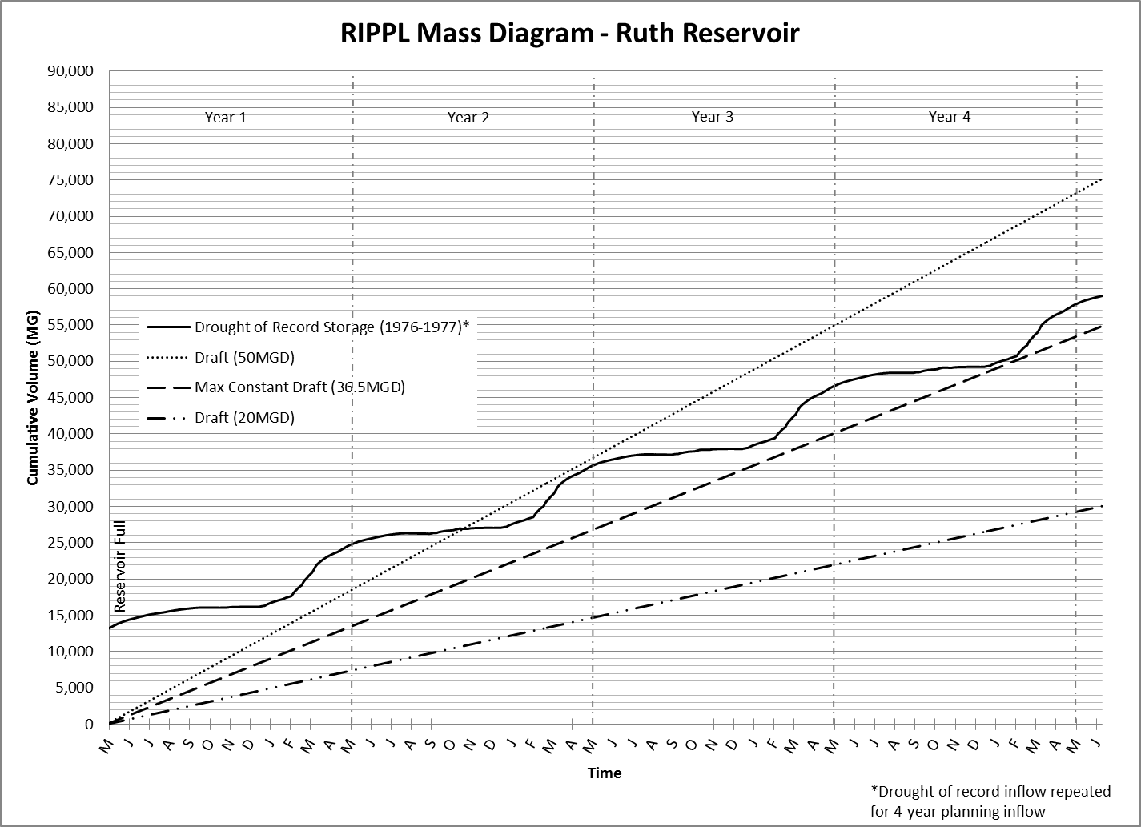

Figure 6. Rippl Mass Diagram

## Stages of Action

There are five defined drought action stages (see Tabl). These stages may be implemented with or without a formal declaration of a water emergency by the District’s Board of Directors. In the event circumstances merit or require a declaration of a water shortage emergency, it is the intent of the District to rely on this plan to provide the primary framework to deal with such an emergency. The triggers attached to each stage are not intended to be absolute. Circumstances not currently foreseeable may dictate moving to a higher action stage before the trigger levels for that stage are reached. Conversely, action stage implementation may be postponed or suspended if there is sufficient natural flow in the river to meet downstream needs. Action stages will be terminated, in consultation with the Water Task Force, as rain, runoff, and lake levels permit.

### Stages and Conditions

An analysis was performed to develop updated reservoir operating curves and establish “action stages” or “trigger levels” that prompt various responses, dependent upon reservoir levels at various times of the year. The analysis established five drought action stages and associated maximum draft rates in the form of an Operating Curve (Figure). This Operating Curve outlines the specific water supply conditions that are applicable to each stage. Stage implementation will occur as a result of the reservoir level at a given time of year, as shown in Figure. For example, if the reservoir storage level was at 25,000 acre-feet in November, Stage 2 would be implemented.

Portions of water demand that need to be included when considering draft from the reservoir include domestic use, industrial use, and instream flow dedications. The municipalities that HBMWD serves currently use an average of approximately 10 MGD of District water. There are currently no industrial customers; however, there is potential for industrial customers in the future. There is also a minimum of 5 cfs that is to be released from the dam for fish flows. The District’s Habitat Conservation Plan and Water Rights permit also establish fish flows that must always be present in the river (see Table 8-1).

Table 8-1: Mad River Flow Requirements for Fish

|  |  |
| --- | --- |
| **Period** | **Flow at Hwy 299 Bridge (cfs)** |
| October 1 – October 15 | 30 |
| October 16 – October 31 | 50 |
| November 1 – June 30 | 75 |
| July 1 – July 31 | 50 |
| August 1 – August 31 | 40 |
| September 1 – September 30 | 30 |

The flow values given in Table 8-18-1 are the flows that need to be measured at the Highway 299 bridge near the District’s operation facilities at Essex, and they do not necessarily reflect flows that need to be released from the reservoir, as there are contributing flows to the Mad River below the reservoir. Furthermore, flows at the Highway 299 bridge are permitted to be as low as the “natural flow” calculation if that value is lower than those given in Table 8-18-1. The District will always maintain the minimum of 5 cfs as required, and has historically endeavored to meet the minimum flows as established in Table 8-18-1 to support healthy fish life. However, it is likely that in the event of a longer-term drought and during periods of the higher conservation Stages being enacted, the District may resort to the natural flow requirement and reduce discharges accordingly.

For the purpose of determining trigger responses, the following assumptions were made:

* The District is operating both its domestic and industrial systems.
* A domestic water delivery of 10 MGD and an industrial water delivery of 40 MGD were used. Although the industrial water system is not currently in use, this assumption accounts for the potential for future industrial water demand. It should also be noted, however, that the Operating Curve is based on total flow released from the reservoir (e.g. in Stage 2, 50 MGD can be released), and this flow can be apportioned based on domestic and industrial water consumption at that point in time.
* Because instream flow dedication requirements vary throughout the year, and can vary depending upon natural flow conditions, these flows were not included. However, flows released from the dam during the various action stages are generally above the flows that are required per Table 8-18-1.

Table 8-2: Drought Triggers Action Table

|  |  |  |  |  |  |  |  |
| --- | --- | --- | --- | --- | --- | --- | --- |
| **Stage** | **Domestic Reduction** | **Industrial Reduction** | **Total Percent Supply Reduction** | **Delivered Water (Municipal, MGD)** | **Delivered Water (Industrial, MGD)** | **Total Delivered (MGD)** | **Maximum Draft (MGD)** |
| 1 | 0% | 0% | 0% | 10 | 40 | 50 | 75 |
| 2 | 5% | 5% | 5% | 9.5 | 38 | 47.5 | 50 |
| 3 | 10% | 50% | 42% | 9 | 20 | 29 | 30 |
| 4 | 20% | 70% | 60% | 8 | 12 | 20 | 20 |
| 5 | 30% | 95% | 82% | 7 | 2 | 9 | 10 |

The operating curves that were established (Figure 7) give maximum draft rates for each of the five different drought action stages. The conservation action boundaries were developed based on these maximum draft rates, the amount of storage remaining over time at a given draft rate, drought of record (1976-1977) inflow, typical evaporation losses, and common reservoir level trends during the period of record (1969-2013). Throughout the period of record, reservoir levels have generally been lowest from October to January, and highest from March to May. The trigger levels have been established to account for these seasonal variations (e.g. a storage level of 30,000 AF would be in Stage 1 in November, but it would be in Stage 3 in May).

To give a context of historical trends of Ruth Lake storage levels, the reservoir levels during the 1976-1977 drought are also shown on Figure7. The storage during the drought follows the general pattern of the operating curves that have been generated. During the drought, reservoir storage never dropped below 10,800 AF.

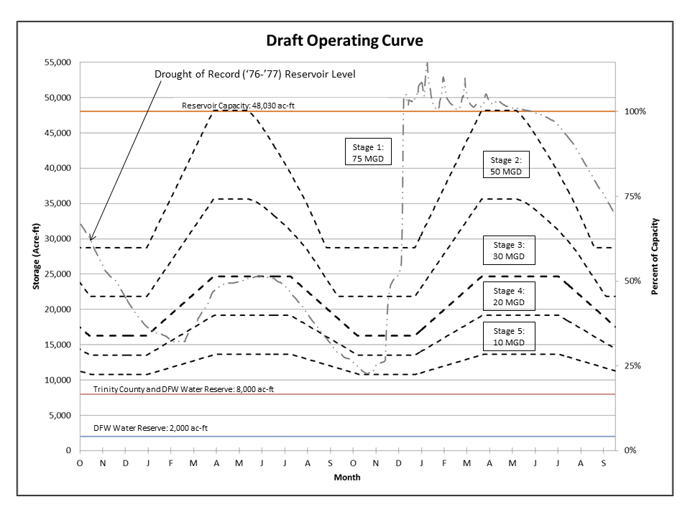

Figure 7: Ruth Lake operating curves

As the District, through its Water Resource Planning efforts, plans to service wholesale industrial water users in the future, the action stages and conditions are given with the assumption that the District is still operating at normal levels prior to loss of its wholesale industrial customers (i.e. 40 MGD is being supplied to industrial customers, and 10 MGD is being supplied to domestic customers). Without wholesale industrial customers, triggering of these stages would not occur as quickly and may not occur at all. Following is a narrative describing the stages given in Tabl in further detail.

Stage 1 – Controlled Release from Storage

If the reservoir level is within the Stage 1 boundaries, only the amount of water needed for instream flow dedication and water supply purposes will be released from the reservoir.

Stage 2 – Optimizing Available Supply

Consideration to implement Stage 2 (50 MGD maximum draft rate) will be triggered when the storage in Ruth Lake falls below the 75 MGD operating curve. Other triggers to be considered for entering into the Stage 2 requirements include are damage to the system by flood, earthquake, or other system failures; and accidental or intentional toxic spills in the supply. The Water Task Force will review the trigger data and make recommendations regarding actual implementation of Stage 2.

In this stage, the draft rate will be limited to 50 MGD or less. Given current water consumption rates, reductions in water delivery may not need to be made to achieve this; however, entering Stage 2 means that awareness needs to be raised and customers need to begin public outreach and education, and potentially voluntary conservation measures. Customers will be notified of potential future reductions, and public education efforts encouraging water conservation should take place. If required, industrial and domestic deliveries will each be reduced by 5% (down to 38 MGD and 9.5 MGD, respectively). Shutting down hydro-electric production should also be considered, as hydro-electric production is incidental to water supply needs and not justification for releases.

Stage 3 – General Reduction

Consideration to implement Stage 3 will be triggered when the storage in Ruth Lake falls below the 50 MGD operating curve. The Water Task Force will review the trigger data and make recommendations regarding actual implementation of Stage 3.

If the reservoir storage level is within the Stage 3 boundaries, the draft rate will be limited to a maximum draft rate of 30 MGD. Based on current demand, domestic use will be reduced by 10% (down to 9 MGD), and delivery to industrial customers will be reduced by 50% (down to 20 MGD). Changes to the specific reduction will be determined on a biweekly basis based on rate of supply reduction, weather, and other relevant factors.

Stage 4 – Usage Allocations

Consideration to implement Stage 4 will be triggered when the storage in Ruth Lake falls below the 30 MGD operating curve. The Water Task Force will review the trigger data and provide input regarding actual implementation of Stage 4.

If the reservoir storage level drops into Stage 4, all of the District’s wholesale and retail customers will be required to reduce usage by the amount necessary to limit consumption to 20 MGD. Domestic use will be reduced by 20% (down to 8 MGD), and industrial deliveries will be reduced by 70% (down to 12 MGD). Furthermore, each wholesale industrial customer will provide certification that water use is being optimized and that wasteful use of water is not occurring. Changes to the specific reduction will be determined on a biweekly basis based on rate of supply reduction, weather, and other relevant factors.

Stage 5 – Rationing

Consideration to implement Stage 5 will be triggered when the storage in Ruth Lake falls below the 20 MGD operating curve. The Water Task Force will review the trigger data and provide input regarding the actual implementation of Stage 5.

If the reservoir storage level reaches Stage 5, the District’s wholesale and retail customers will be limited to a total usage of 10 MGD. Wholesale industrial water usage will be limited to the amounts required for human consumption, sanitation, and fire protection. No water will likely be available for industrial processes. Domestic reduction will be approximately 30%. Municipal and retail customer usage will be reassessed on a bi-weekly basis and may be adjusted as determined by the rate of use of available supply and weather conditions.

## Prohibitions on End Uses

The District does not have the ability to impose use restriction or other requirements directly on end users of the wholesale municipal customers’ water. Each wholesale customer is responsible for adopting plans to implement the reductions in water use called for by the action stages outlined above. Effectiveness of this plan will be monitored on a daily basis using continuously metered data from Ruth Lake and the metered connections to all wholesale municipal and industrial customers.

## Penalties, Charges, Other Enforcement of Prohibitions

As noted earlier in this plan, each wholesale customer is responsible for adopting plans to implement the reductions in water use called for by the action stages outlined above. Effectiveness of this plan will be monitored on a daily basis using continuously metered data from Ruth Lake and the metered connections to all wholesale municipal and industrial customers.

|  |  |
| --- | --- |
| **Examples of Prohibitions** | **Stage when Prohibition Becomes Mandatory** |
| Domestic use limited to 9 MGD, and industrial use limited to 20 MGD | 3 |
| Domestic use limited to 8 MGD, and industrial use limited to 12 MGD | 4 |
| Domestic use limited to 7 MGD, and industrial use limited to only the amounts required for human consumption, sanitation, and fire protection | 5 |

**Table 8-1** shows examples of prohibitions and the stage when those prohibitions become mandatory. These prohibitions assume that the District is operating at normal levels prior to loss of its industrial customers.

|  |  |
| --- | --- |
| **Examples of Prohibitions** | **Stage when Prohibition Becomes Mandatory** |
| Domestic use limited to 9 MGD, and industrial use limited to 20 MGD | 3 |
| Domestic use limited to 8 MGD, and industrial use limited to 12 MGD | 4 |
| Domestic use limited to 7 MGD, and industrial use limited to only the amounts required for human consumption, sanitation, and fire protection | 5 |

**Table 8-1: Water Shortage Contingency – Mandatory Prohibitions**

## Consumption Reduction Methods

As previously mentioned, the District does not have the ability to impose use restriction or other requirements directly on end users of the wholesale customers’ water. Each wholesale customer is responsible for adopting plans to implement the reductions in water use called for by the action stages outlined above. The District will also perform general voluntary water conservation measures in conjunction with its wholesale customers, as well as perform public education efforts to encourage water conservation. As storage levels in the reservoir drop, the District will work closely with its wholesale customers to attempt to minimize water consumption in the area, as well as minimize their own internal use. However, their internal usage is minimal, but items such as line flushing will be discontinued or kept to a bare minimum as required.

While the District does not have the ability to limit the amount of water delivered to its wholesale customers, the District does have the ability to limit water delivered to potential industrial customers. Should a drought situation arise where action is required, delivery to industrial customers will be reduced as outlined in Section 8.1. Table 8-2 gives a summary of the consumption reduction methods and the stages when the method will take effect.

Table 8-2: Consumption Reduction Methods

|  |  |
| --- | --- |
| **Consumption Reduction Methods** | **Stage when Method Takes Effect** |
| Release from storage only amount of water needed for in-stream and water supply purposes | 1 |
| General voluntary water conservation measures with wholesale customers | 2 |
| Public education efforts encouraging water conservation | 2 |
| Encourage all wholesale and retail customers to reduce usage. Require industrial customers to reduce usage. | 3 |
| Encourage all wholesale and retail customers to reduce usage further. Require industrial customers to further reduce usage. | 4 |
| No water for industrial processes and reduce wholesale and retail customer usage up to 50% | 5 |

## Determining Water Shortage Reductions

The District has water meters in place at all of the connections to the systems of each of its seven wholesale municipal customers. There are also meters at every residential connection, and a meter will be installed at any future industrial customer connection. To determine the actual reductions in use of water during a water shortage, the District will use its Supervisory Control and Data Acquisition (SCADA) system to monitor distribution to its customers on a daily basis. In the event of a power outage, the District has two auxiliary power generators as standby power sources. The first generator is a 35 kW (kilowatt) generator and the second is a 2 MW (megawatt) generator. Therefore, the SCADA system will continue operating during power outages and continue monitoring distribution. Water shortage reductions will be determined by subtracting post-drought consumption rates from pre-drought consumption rates.

## Revenue and Expenditure Impacts

Each wholesale customer must gage the revenue and expenditure impact of the action stages. The expenditure and revenue impacts on the District are negligible since the wholesale rates are designed to cover costs incurred by the District in producing and distributing the water. With less water to produce, there would be less expense incurred by the District. Therefore, expenditures and revenues for costs directly related to the amount of water produced (e.g. costs for power for pumping) will both decrease as deliveries of water are curtailed. If the shortage were to continue for a prolonged period, the District could reduce staff in order to cut costs as the District would not be producing and distributing water at normal levels. The District also has a reserve account to act as a buffer to cover fixed costs for a short period of time if the District were to need it.

## Resolution or Ordinance

A copy of the District’s draft Water Shortage Contingency Resolution for declaring a water shortage emergency and implementing the District’s Water Shortage Contingency Plan is attached as Appendix F.

## Catastrophic Supply Interruption

The District‘s Emergency Operations Plan (EOP) provides the overall response procedures for catastrophic supply interruptions. The EOP further provides specific procedures for power outages and for security incidents. The District‘s Emergency Action Plan (EAP) provides response procedures for catastrophic supply interruptions involving the R.W. Matthews Dam and Reservoir (Ruth Lake), such as an earthquake. The District‘s Operations Plan (OP) provides procedures for system failures. Hazardous materials incidents are covered by numerous response plans depending on the nature of the incident. Table 8-3 summarizes possible catastrophe events and the actions that would be taken or plans that would be implemented for each scenario.

Table 8-3: Preparation Actions for a Catastrophe

|  |  |
| --- | --- |
| **Possible Catastrophe** | **Summary of Actions/Plans** |
| Regional Power Outage | Emergency Operations Plan-Power Outage Procedures |
| System Failure | Operations Plan for Water Supply, Treatment, and Distribution System |
| Earthquake | Emergency Operations Plan/  Emergency Action Plan (R.W. Matthews Dam at Ruth) |
| Hazardous Material Spill | Hazardous Materials Response Plans |
| Acts of Terrorism | Emergency Operations Plan-Security Procedures/ Emergency Action Plan (R.W. Matthews Dam at Ruth) |

## 

## Minimum Supply Next Three Years

The three water years between October 1989 and September 1992 represent the driest three-year period recorded for the District:

* Rainfall for this period averaged 42 inches per year (60% of normal).
* Of the three water years, the driest year for rainfall was water year 1990/1991 with 37 inches (53% of normal).
* Flows into Ruth Lake above Zenia averaged 69,000 AFY, or 40% of normal (173,000 AFY).
* The runoff for the watershed above the District‘s diversion facilities was 371,300 AFY, or 39% of normal (959,071 AFY).
* Despite the diminished rainfall and runoff, rainfall was more than sufficient to refill the reservoir each year.
* Reservoir volume during this period averaged 37,000 AF which is 77% of capacity (48,030 AF) and 90% of normal (41,000 AF).

A plot of reservoir levels over the course of each respective water year from October 1989 through September 1992 is given as Figure 8. This figure shows that even in the three driest consecutive years of record, the reservoir still reached maximum capacity for each of the respective years and generally remained full for months each year. Furthermore, the District was still supplying industrial water during this time, whereas the District is currently only supplying domestic water. Given this, in the event that the next three years are hydrologically the same as the driest three consecutive years of record, the minimum available supply would be greater than the full reservoir level of 48,030 acre-feet for each year, as shown in Table 8-6.

Table 8-4: Minimum Supply Next Three Years

|  |  |  |  |
| --- | --- | --- | --- |
|  | **2016** | **2017** | **2018** |
| **Available Water Supply** | > 48,030 AF | > 48,030 AF | > 48,030 AF |

A Rippl mass diagram was generated (Figure9) using the same assumptions as given in Section 8.2 to plot the cumulative inflow to the reservoir (less evaporation) and various cumulative draft rates. As seen in the figure, a constant draft rate of 38.5 MGD could be achieved if the hydrologic conditions of the drought of record (1976-77) were to be synthetically repeated for a three-year planning period. Current usage is approximately 10 MGD. Therefore, even if the single-year drought of record were repeated for three years, the District would still have a more than adequate water supply to serve its current customers’ needs.

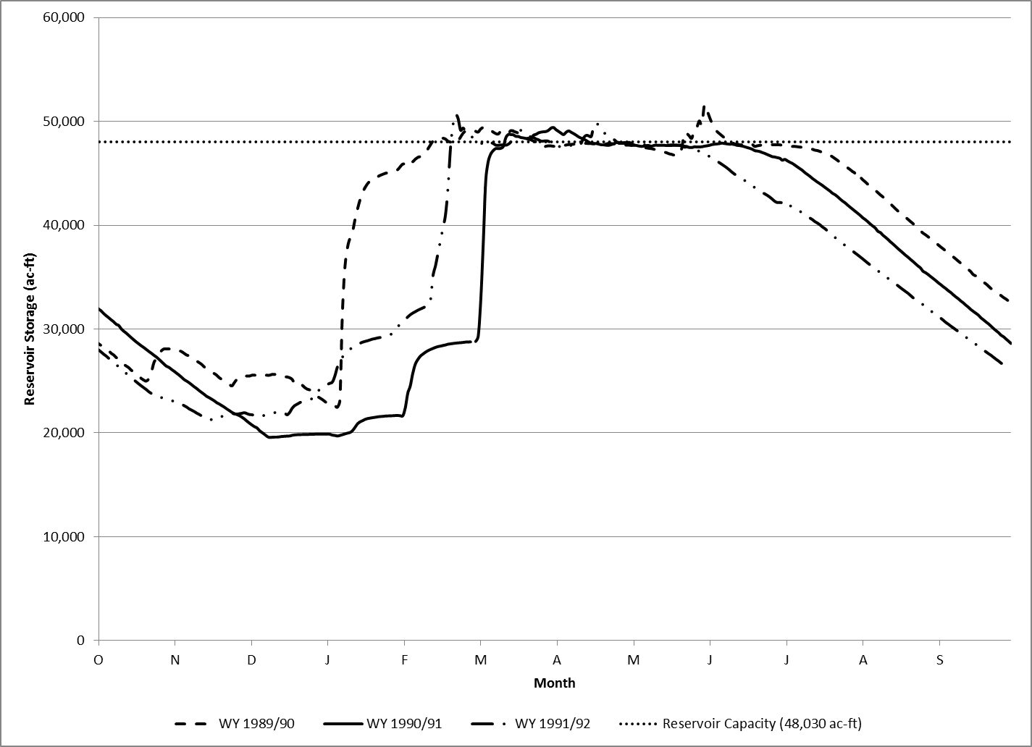

Figure 8: Ruth reservoir water storage levels for the driest three consecutive years of record

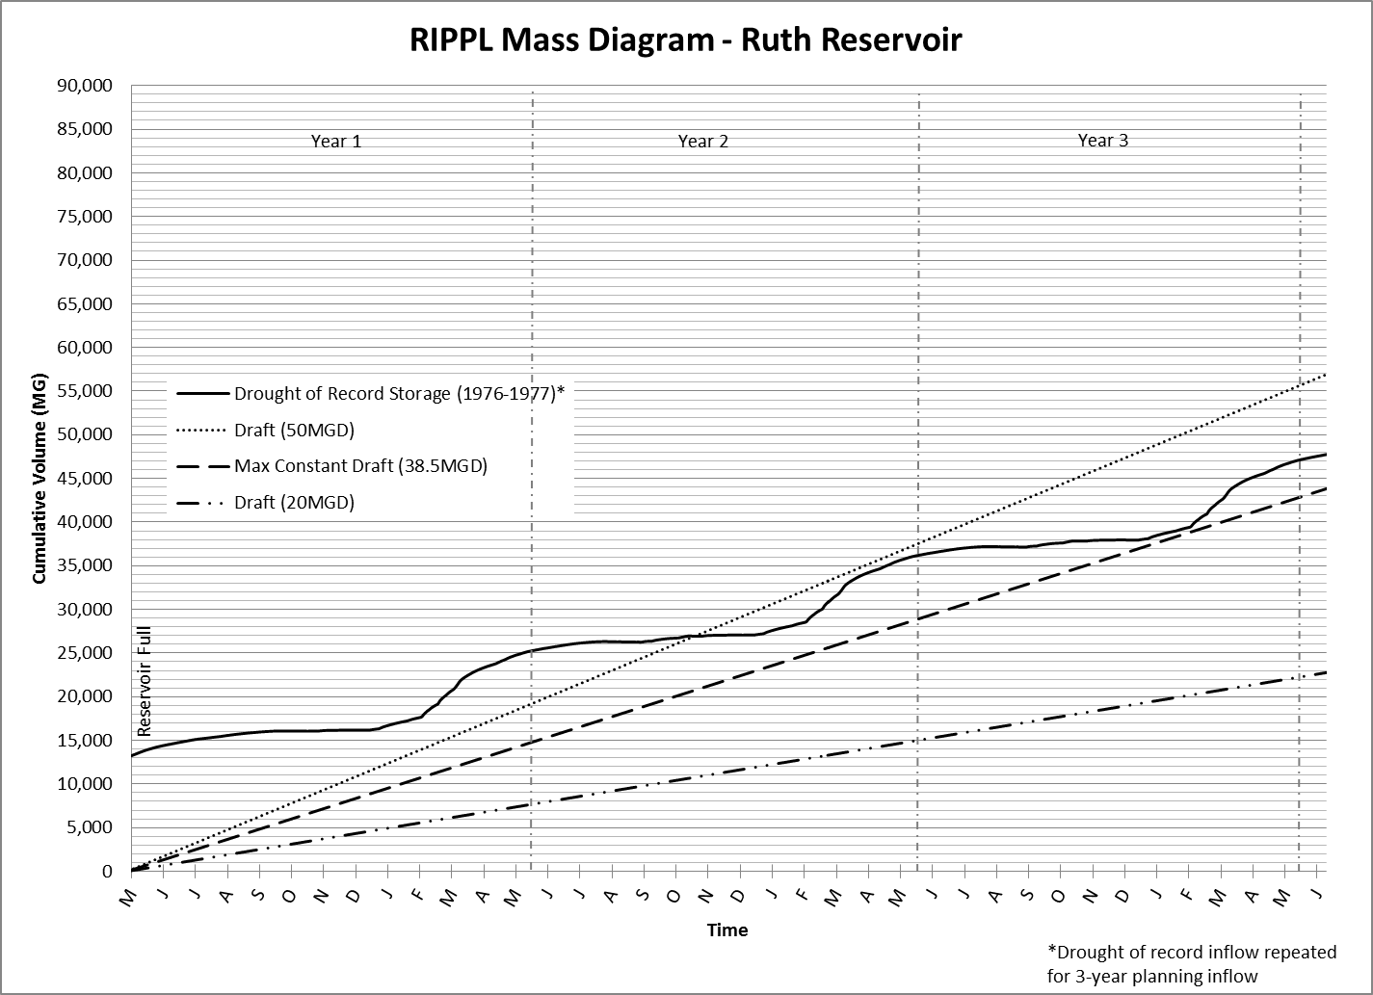

Figure 9: Rippl Mass Diagram with ’76-’77 drought hydrologic information repeated for a three-year planning period

# Demand Management Measures

## Demand Management Measures for Wholesale Agencies

The area served by the District is one of the few regions of California with a local abundance of water. This has meant that droughts, while just as severe climatically, have not led to the same level of supply shortfall as in many other regions. This does not mean that the District or its residents are unaware or unconcerned about the importance of water conservation.

Because supplies are sufficient to meet current and projected demand and per capita use is low, implementing additional Demand Management Measures (DMMs) beyond those that are required of the District as an urban water wholesaler is not economic for the District.

Throughout the Work Group meetings and entire process of completing this UWMP, the District has asked the four larger wholesale customers (who were also working on their UWMPs) if there were any programs or any assistance they need from the District with regards to helping them achieve their water use targets. The District has also offered its assistance on any DMM programs that the wholesale customers may have. During the past five years, the District has supported and contributed financially and with staff time in helping the other four larger wholesalers with their public education and outreach on water conservation. These outreach activities are listed in Section 9.3. The District will continue to support and work with its wholesale customers to help them achieve their water use targets and DMMs. If any of the wholesale customers identifies a program to help them achieve their water-use targets or DMMs in the coming months or years, the District will consider and implement as appropriate.

DWR requires wholesale urban water suppliers to address the following DMMs (labeled according to Guidebook):

* (*ii*) Metering.
* (*iv*) Public education and outreach.
* (*vi*) Water conservation program coordination and staffing support.
* (*vii*) Other demand management measures.
* Asset management.
* Wholesale supplier assistance programs.

### Metering

The District has meters on all services and sources. The existing connections to the District’s wholesale customers are metered and monitored regularly for leaks and waste. If a new wholesale customer were to join the District, the connection would be metered. Totalizers connected to the District’s control system measure and record production rates as well as delivery rates to all wholesale customers. These readings are taken continuously and are monitored at all times by the District’s Water Plant Operators. Any issues dealing with leaks and waste, along with other water related topics are discussed at the District’s monthly Muni-Meetings, which the District implements as part of its Wholesale Agency Programs.

The District conducts regularly scheduled flow testing, calibration and maintenance of all its wholesale water meters. This ensures that the meter readings are accurate and helps the District and its wholesale customers monitor for leaks and waste. The District’s wholesale customers (urban retail water suppliers) will conduct review of their own metering and retrofit programs for end users in their UWMPs.

### Public education and outreach

The District supports initiatives to inform the public about water conservation. In the past, the District has made financial contributions to the California Water Awareness Campaign and the Water Education Foundation. These organizations are involved with providing water education and promoting water conservation statewide. The District also supported and developed public outreach and awareness programs through radio, newspapers, public access television, and information booths at the county fairs, farmers markets and local zoo events.

District personnel at the Essex Operational Center give tours of the water production and treatment facilities to students. These tours have varied from the most basic water awareness talks for kindergarten classes to technical presentations for graduate engineering classes. Personnel have also assisted individual high school and university students with their projects relating to either the water system or the Mad River. The District enjoys the opportunity to work with students as it is rewarding to all involved and helps to disseminate awareness of water as a valuable resource and to practice conservation.

In the future, the District will continue efforts to raise public awareness of water conservation issues with its wholesale customers (urban retail water suppliers) by helping to develop and co-fund public awareness programs through radio, newspapers, information booths, presentations, and other media.

### Water conservation program coordination and staffing support

In compliance with this DMM, the District has designated a Water Conservation Coordinator, whose responsibilities include program management, tracking, planning and reporting on implementation of the DMMs. The Water Conservation Coordinator for the District is its Program and Regulatory Analyst.

### Other demand management measures

***Conservation pricing***

The District has individual wholesale contracts with each of its wholesale customers. These contracts include both a fixed fee component and a variable-fee component based on water use. The variable fee component is a uniform rate set for each wholesale customer that is charged per volume of water used. A set peak rate has also been allocated to each wholesale customer so that they cannot continually exceed that peak rate without discussing this amount with the District and negotiating a new peak rate. The current rate structure between the District and its wholesale customers encourages conservation by providing the wholesale customers a means to reduce water costs with reduction in water use.

***Enacting Prohibited Activities in Promotion of Water Conservation***

Since August 2014 and throughout 2015 and 2016, the District has enacted Prohibited Activities in Promotion of Water Conservation, as required by State Emergency Conservation Regulations. These prohibited activities include:

1. The application of potable water to outdoor landscapes in a manner that causes runoff such that water flows onto adjacent property, non-irrigated areas, private and public walkways, roadways, parking lots, or structures;
2. The use of a hose that dispenses potable water to wash a motor vehicle, except where the hose is fitted with a shut-off nozzle or device attached to it that causes it to cease dispensing water immediately when not in use;
3. The application of potable water to driveways and sidewalks; and
4. The use of potable water in a fountain or other decorative water feature, except where the water is part of a recirculation system;
5. The use of outdoor irrigation during and 48 hours following measurable precipitation;
6. The use of outdoor irrigation of turf or ornamental landscapes is limited to the following two days per week: Wednesday and Saturday;

These prohibited activities are listed in the Board approved resolutions included in Appendix H.

### Asset management

The District has a comprehensive distribution system asset management program that includes use of a geographical information system (GIS) and a Capital Improvement Plan (CIP). The District maintains a GIS program to keep track of its distribution system. The GIS program contains multiple layers of data and information, including layers for different boundaries, pipelines, meters, backflow devices, structures, easements, and images. The District is able to produce location maps and specific data layer maps of any location in its distribution system when needed.

The District’s CIP was approved by our Board in late 2011. The CIP establishes a policy framework to identify and prioritize necessary capital improvement and replacement projects on the regional water system. It is a multi-year planning instrument intended to identify projects that will ensure the regional system reliably meets our communities’ water supply needs in a cost-effective manner.

The purposes of this CIP are to:

1. Summarize the history of development of the regional water system;
2. Identify the extensive asset inventory associated with the regional water system and document its age and condition;
3. Develop policies to guide the District’s infrastructure investments;
4. Identify and prioritize infrastructure projects to support the District’s mission;
5. Develop a long-term CIP;
6. Develop a financial plan with options and recommendations to fund the proposed CIP projects;
7. Communicate the infrastructure needs to the District’s wholesale municipal customers and the community at-large; and
8. Position the District, and possibly its wholesale customers, for state and federal grant funding opportunities.

This CIP is intended to be a “living document” that will be updated based on changing needs or circumstances. It will be used to identify and communicate priorities, allocate resources, and track progress. It is also intended to guide future District budgets, and assist the District’s wholesale customers with their financial planning and rate studies. Most importantly, the CIP will directly support the District in its mission to reliably supply and deliver high-quality water to customers in the Humboldt Bay region.

### Wholesale supplier assistance programs

The District and its wholesale customers work together to identify options to reduce water waste, improve water use efficiency, and educate the end users about conservation practices. These efforts occur during the monthly “Muni-Meetings” coordinated and hosted by the District. The wholesale customers attend these monthly meetings, which are the forum that is intended to foster this type of partnership between the retail agencies and the District. Examples of recent coordination efforts are described below:

* The District hosts and leads monthly water conservation discussion and UWMP planning meetings with the four larger water agencies; Cities of Eureka and Arcata, and Humboldt and McKinleyville Community Services Districts, forming the Northcoast Region Water Conservation Group (conservation group). The conservation group was formed with the intention of sharing resources, including the cost of program implementation, and to provide a consistent conservation message throughout the region.
* The District provides educational material and water use data to the wholesale customers for distribution to the end users, to assist the wholesale agencies in understanding their demand.
* Separate from the conservation group mentioned above, the District conducts monthly Muni-Meetings where conservation topics are discussed and when practical, the District assists the wholesale agencies with the development of their respective UWMPs.

## Demand Management Measures for Retail Agencies

This section applies to Retail service water agencies only.

## Implementation over the Past Five Years

Over the past five years, the District has participated in various public education and outreach activities with the other four larger water agencies (Cities of Eureka and Arcata, and Humboldt and McKinleyville Community Services Districts), forming the Northcoast Region Water Conservation Group (conservation group). As mentioned in Section 9.1.6, the conservation group was formed with the intention of sharing resources, including the cost of program implementation, and to provide a consistent conservation message throughout the region, which in large part shares the same water supplied by the District. The District’s Water Conservation Coordinator, its Regulatory & Program Analyst, lead the monthly meetings conservation group meetings and participated in and helped plan the public education and outreach activities below.

Public education and outreach activities implemented by the conservation group include:

• *Water Ads*. The District participated in a water conservation radio ad campaign consisting of 30-second radio ads highlighting different water conservation messages for broadcast on three local radio stations over two six-month periods (May – October) in 2014 and 2015. The District is continuing to support this outreach activity in 2016 and will continue to evaluate the effectiveness of this program in the future.

• *Tabling/informational displays at public events*. In 2014 and 2015, the conservation group entered an informational display at the annual Humboldt County Fair. The display consisted of a variety of water education and conservation information (Figure 8). In 2015, the display was awarded the Best of Show award for the adult feature exhibit category. City of Arcata staff tabled at several Farmer’s Market events in 2015 in an effort to provide educational materials about water conservation. In 2016, the conservation group participated in the “Party for the Planet” event at the Sequoia Park Zoo and will participate in the annual Humboldt County Fair. The District and the conservation group will continue to identify tabling/informational display opportunities in the community.



Figure 10. Northcoast Region Water Conservation Group display at Humboldt County Fair. (Photo by David Hull of Humboldt CSD)

• *Water Week*. The conservation group’s informational display was set up during the City of Arcata’s Water Week during May 2015 and 2016, in celebration of the beneficial uses of water. Water week activities included a youth poster contest, water and wastewater facility tours, a scavenger hunt game with prizes for kids and adults, classroom presentations, and a booth at the Arcata Farmer’s Market. The conservation group will continue to support the City of Arcata’s Water Week events in the future.

• *Presentations*. Representatives of the water conservation group prepared a PowerPoint presentation focusing on water conservation for community groups. Presentations were made to local chapters of the Daughters of the American Revolution and Soroptimist International. The conservation group will continue to offer presentations to organizations expressing interest.

• *Conservation materials*. In an effort to comply with the State’s emergency water conservation reduction requirement (4 percent reduction required), the District coordinated with the conservation group and printed a variety of materials for distribution and use throughout the community, including door hangers, handouts, and post cards. The District will continue to evaluate the effectiveness of these activities.

• *Notifications to retail customers*. The District has continued to notify its approximately 200 retail customers regarding the State’s emergency water conservation regulations and requirements. New notices were mailed to our retail customers each time there was an update to our water conservation regulations.

• *Promoting state programs*. The District recognizes that California’s “Save our Water” program is a valuable free resource for conservation information and materials. The District actively promotes the program by providing links to saveourwater.com and saveourwaterrebates.com on the District’s website ([www.hbmwd.com](http://www.hbmwd.com)) and printed materials. The District primarily used graphics from the Save Our Water Toolkit for public education and outreach events. The District and conservation group will continue to use this valuable resource in the future.

## Planned Implementation to Achieve Water Use Targets

This section applies to Retail service water agencies only.

## Member of the California Urban Water Conservation Council

The District is not a member of the California Urban Water Conservation Council, therefore, this section does not apply to the District.

# Plan Adoption, Submittal, and Implementation

Appendix B includes a copy of the following documents:

* 60 Day Notification of UWMP Review and Adoption Hearing
* Certificate of Publication of the Legal Notice of Public Hearing (from The Time-Standard, Mad River Union, and North Coast Journal Inc.)
* District’s Board Agenda for the June 9, 2016 meeting, showing Item I.1 – Public Hearing and Resolution No. 2016-6 Adopting the District’s 2015 UWMP
* Board Resolution No. 2016-06 Adopting the District’s 2015 UWMP
* Proof of Plan Submittal to DWR and other agencies
* Documentation showing that Adopted UWMP was available for public review
* Sample 2015 UWMP Work Group Meeting Agenda and meeting documents
* Notification of Public Hearing to Agencies with Land Use Planning Authority and the District’s Municipal Customers

## Inclusion of All 2015 Data

The District’s 2015 UWMP includes water use and planning data for the entire calendar year of 2015. Water use data for calendar year 2015 is included in the District’s water audit (Appendix I).

## Notice of Public Hearing

The District notified its wholesale customers, the communities served, land-use planning agencies, and the County of Humboldt of the time and place of the public hearing (Appendices B-2 and B-8).

Pursuant to Section 6066 of the Government Code, Notice of Public Hearing was published in both the Times Standard and Mad River Union newspapers on May 25, 2016 and June 1, 2016 and was posted at the District’s Eureka main office. The District’s 2015 UWMP was also available for public review at our main office in Eureka.

Notice of Public Hearing was provided to Humboldt Couty, City of Arcata, City of Eureka, City of Blue Lake, Humboldt CSD, McKinleyville CSD, Fieldbrook-Glendale CSD, and Manila CSD on May 23, 2016 (Table 10-1 W).



## Public Hearing and Adoption

The District held its public hearing for the 2015 UWMP at its regularly scheduled Board meeting on June 9, 2016. Following the hearing, the District’s Board adopted the UWMP as prepared. The following documents relating to the public hearing have been included:

* Certificate of Publication of the Legal Notice of Public Hearing (B-2)
* District’s Board Agenda Notice of Public Hearing (B-3)
* Board Resolution Adopting the District’s 2015 UWMP (B-4)

## Plan Submittal

The District’s 2015 UWMP shall be submitted to the DWR within 30 days of adoption and no later than July 1, 2016. Submittal of the 2015 UWMP shall be through DWR’s Water Use Efficiency data online submittal tool. No later than 30 days after adoption of the 2015 UWMP, the District shall submit a CD or hardcopy of the adopted 2015 UWMP to the California State Library, and electronic copy to the County of Humboldt, and the cities and community services districts within its service area. Proof of submittal of the plan is included (Appendix B-5).

## Public Availability

The District made its 2015 UWMP available for public review and held a public hearing to receive input.

After adoption of the 2015 UWMP, the District made the plan available for public review at its main office in Eureka, CA as well as on the District’s website ([www.hbmwd.com](http://www.hbmwd.com)). Documentation showing that the adopted UWMP was available for public review is included (Appendix B-6).

## Amending an Adopted UWMP

Any changes to the 2015 UWMP shall be adopted by the District’s Board of Directors. All notification, public hearing, adoptions, and submittal requirements shall be followed for an amended plan.